**Spring Boot**

**Introduction:**

***Spring Boot*** is an open source Java-based framework used to create a micro Service. It is developed by Pivotal Team and is used to build stand-alone and production ready spring applications.

**Micro Service:**

***Micro Service*** is an architecture that allows the developers to develop and deploy services independently. Each service running has its own process and this achieves the lightweight model to support business applications.

### Advantages Of Micro Services:

***A micro service offers*** *the following advantages to its developers* ***–***

* Easy deployment
* Simple scalability
* Compatible with Containers
* Minimum configuration
* Lesser production time

### Spring Boot:

***Spring Boot*** *provides a good platform for Java developers to develop a stand-alone and production-grade spring application that you can just run. You can get started with minimum configurations without the need for an entire Spring configuration setup.*

### Advantages of Spring Boot:

*Spring Boot offers the following advantages to its developers −*

* Easy to understand and develop spring applications
* Increases productivity
* Reduces the development time

### Goals

***Spring Boot*** *is designed with the following goals −*

* *To avoid complex XML configuration in Spring*
* *To develop a production ready Spring applications in an easier way*
* *To reduce the development time and run the application independently*
* *Offer an easier way of getting started with the application*

### Why Spring Boot?

*You can choose* ***Spring Boot*** *because of the features and benefits it offers as given here −*

* *It provides a flexible way to configure Java Beans, XML configurations, and Database Transactions.*
* *It provides a powerful batch processing and manages REST endpoints.*
* *In Spring Boot, everything is auto configured; no manual configurations are needed.*
* *It offers annotation-based spring application*
* *Eases dependency management*
* *It includes Embedded Servlet Container*

### How does it work?

***Spring Boot*** *automatically configures your application based on the dependencies you have added to the project by using****@EnableAutoConfiguration****annotation. For example, if* **MySQL** *database is on your classpath, but you have not configured any database connection, then Spring Boot auto-configures an in-memory database.*

*The* ***entry point*** *of the spring boot application is the class contains****@SpringBootApplication****annotation and the* ***main method****.*

*Spring Boot automatically scans all the components included in the project by using****@ComponentScan****annotation.*

### *Spring Boot Starters:*

*Handling dependency management is a difficult task for big projects. Spring Boot resolves this problem by providing a set of dependencies for developers convenience.*

*For example, if you want to use* ***Spring and JPA*** *for database access, it is sufficient if you include****spring-boot-starter-data-jpa****dependency in your project.*

*Note that all Spring Boot starters follow the same naming pattern****spring-boot-starter- *, where * indicates that it is a type of the application.***

### *Examples*

*Look at the following Spring Boot starters explained below for a better understanding −*

***Spring Boot Starter Actuator dependency****is used to monitor and manage your application. Its code is shown below –*

<dependency>

<groupId>org.springframework.boot</groupId>

<artifactId>spring-boot-starter-actuator</artifactId>

</dependency>

***Spring Boot Starter Security dependency****is used for Spring Security. Its code is shown below −*

<dependency>

<groupId>org.springframework.boot</groupId>

<artifactId>spring-boot-starter-security</artifactId>

</dependency>

***Spring Boot Starter web dependency****is used to write a Rest Endpoints. Its code is shown below*

<dependency>

<groupId>org.springframework.boot</groupId>

<artifactId>spring-boot-starter-web</artifactId>

</dependency>

***Spring Boot Starter Thyme Leaf dependency****is used to create a web application. Its code is shown below −*

<dependency>

<groupId>org.springframework.boot</groupId>

<artifactId>spring-boot-starter-thymeleaf</artifactId>

</dependency>

***Spring Boot Starter Test dependency****is used for writing Test cases. Its code is shown below −*

<dependency>

<groupId>org.springframework.boot</groupId>

<artifactId>spring-boot-starter-test<artifactId>

</dependency>

### *Auto Configuration*

*Spring Boot Auto Configuration automatically configures your Spring application based on the JAR dependencies you added in the project. For example, if* ***MySQL*** *database is on your class path, but you have not configured any database connection, then Spring Boot auto configures an in-memory database.*

*For this purpose, you need to add****@EnableAutoConfiguration****annotation or****@SpringBootApplication****annotation to your main class file. Then, your Spring Boot application will be automatically configured.*

*Observe the following code for a better understanding −*

import org.springframework.boot.SpringApplication;

import org.springframework.boot.autoconfigure.EnableAutoConfiguration;

@EnableAutoConfiguration

public class DemoApplication {

public static void main(String[] args) {

SpringApplication.run(DemoApplication.class, args);

}

}

### *Spring Boot Application*

*The entry point of the Spring Boot Application is the class contains****@SpringBootApplication****annotation. This class should have the main method to run the Spring Boot application.****@SpringBootApplicationannotation*** *includes Auto- Configuration, Component Scan, and Spring Boot Configuration.*

*If you added****@SpringBootApplication****annotation to the class, you do not need to add the****@EnableAutoConfiguration****,* ***@ComponentScan****and****@SpringBootConfiguration****annotation. The****@SpringBootApplicationannotation*** *includes all other annotations.*

*Observe the following code for a better understanding −*

import org.springframework.boot.SpringApplication;

import org.springframework.boot.autoconfigure.SpringBootApplication;

@SpringBootApplication

public class DemoApplication {

public static void main(String[] args) {

SpringApplication.run(DemoApplication.class, args);

}

}

### *Component Scan*

*Spring Boot application scans all the beans and package declarations when the application initializes. You need to add the****@ComponentScan****annotation for your class file to scan your components added in your project.*

*Observe the following code for a better understanding −*

import org.springframework.boot.SpringApplication;

import org.springframework.context.annotation.ComponentScan;

@ComponentScan

public class DemoApplication {

public static void main(String[] args) {

SpringApplication.run(DemoApplication.class, args);

}

}

### *Sample Spring Boot Maven Project:*

*Creating Spring Boot project by creating maven project. It includes the following steps.*

1. *Select project type.*

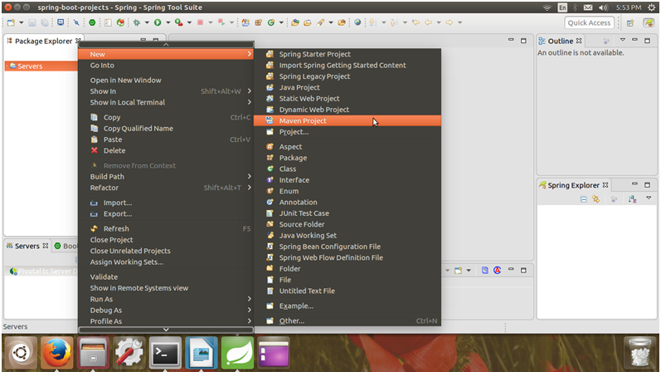

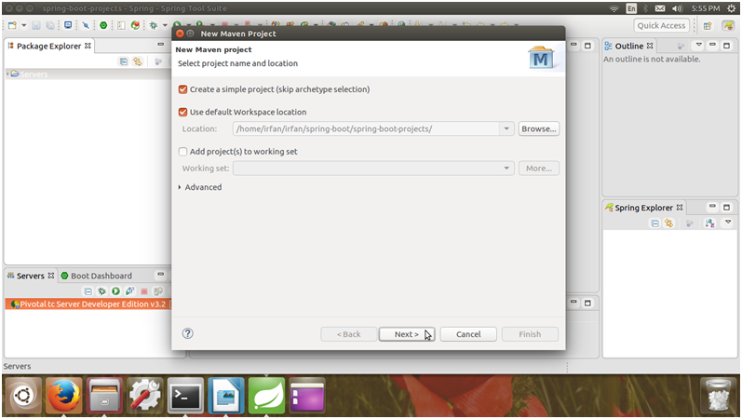

Configure project by providing project name.

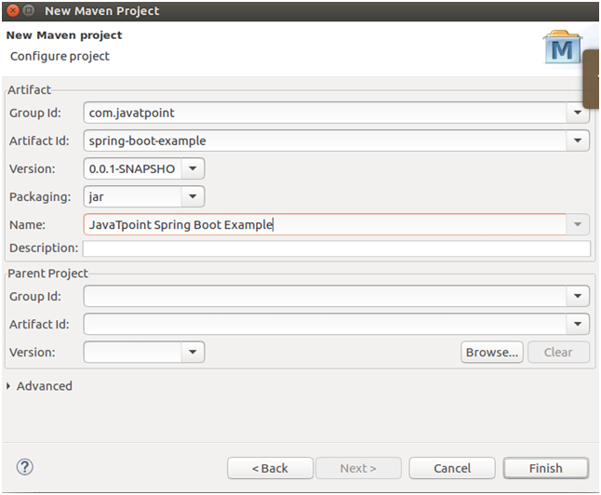

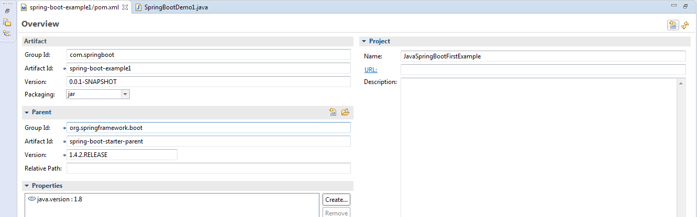

After clicking finish, Spring boot project has been created. Our new project looks like the following screen shot.

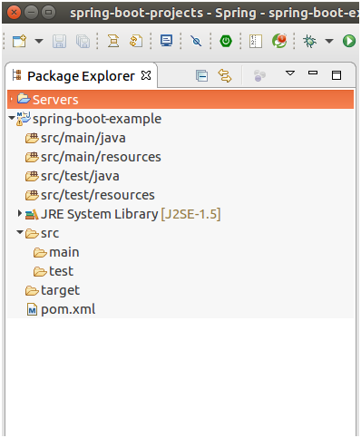

This Maven project has a pom.xml file which contains the following default configuration.

<project xmlns=*"http://maven.apache.org/POM/4.0.0"* xmlns:xsi=*"http://www.w3.org/2001/XMLSchema-instance"* xsi:schemaLocation=*"http://maven.apache.org/POM/4.0.0 http://maven.apache.org/xsd/maven-4.0.0.xsd"*>

<modelVersion>4.0.0</modelVersion>

<groupId>com.springboot</groupId>

<artifactId>spring-boot-example1</artifactId>

<version>0.0.1-SNAPSHOT</version>

<name>JavaSpringBootFirstExample</name>

<parent>

<groupId>org.springframework.boot</groupId>

<artifactId>spring-boot-starter-parent</artifactId>

<version>1.4.2.RELEASE</version>

</parent>

<dependencies>

<dependency>

<groupId>org.springframework.boot</groupId>

<artifactId>spring-boot-starter-web</artifactId>

</dependency>

</dependencies>

<properties>

<java.version>1.8</java.version>

</properties>

</project>

Now, our project should have the following directly structure. You can notice that maven has created a new dependency folder to store the jar files.

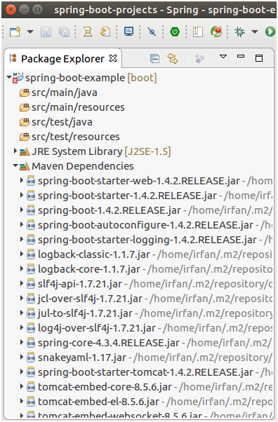

Update Maven project each time after including new dependencies.

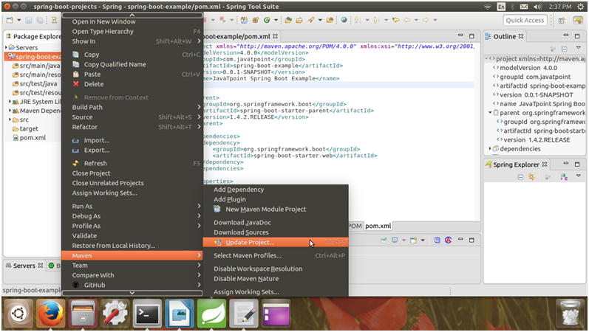

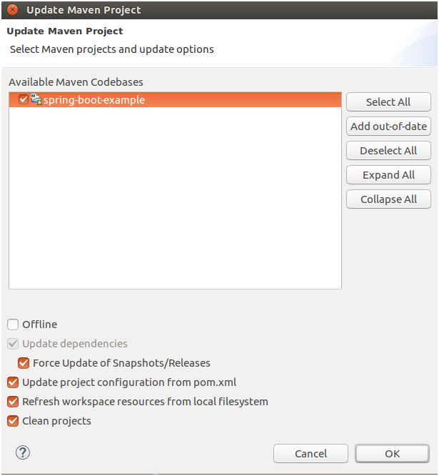

After updating Maven. Now, let's make it runnable. Create a Java class inside the src/main/java package.

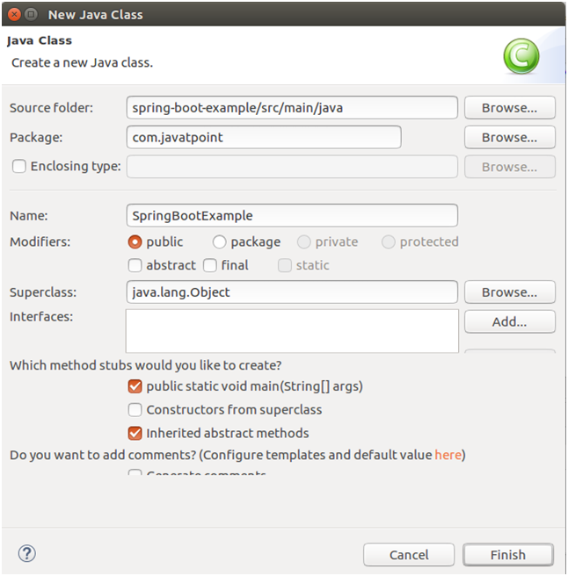

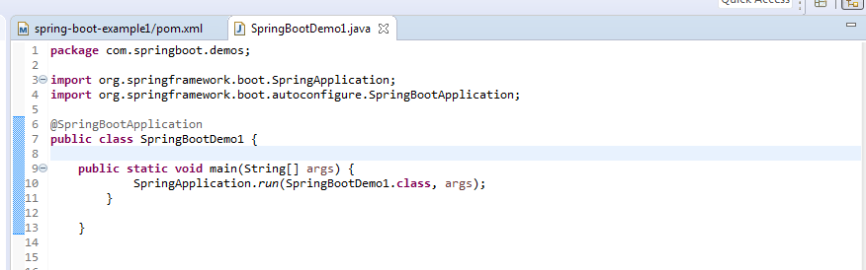

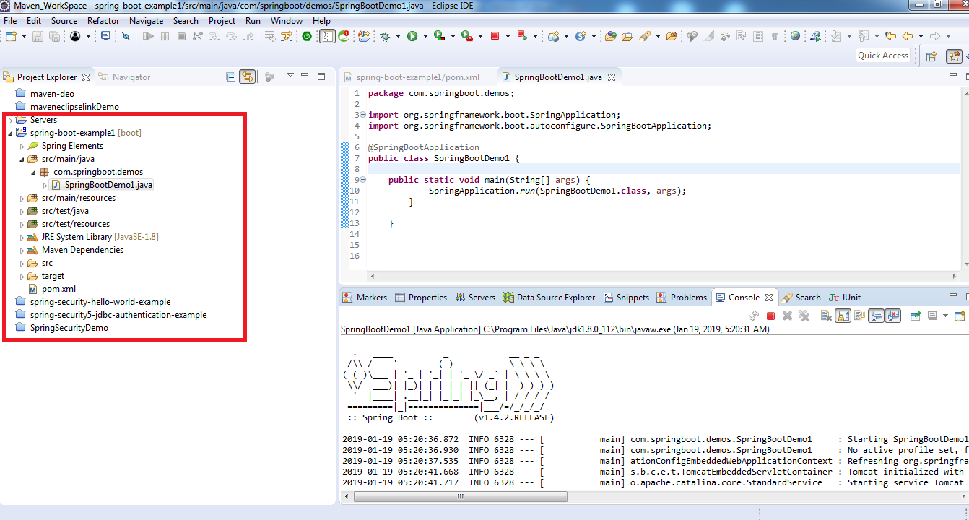

**Second Application using Spring Tool suite:**

1. Launch Spring suite tool Ide and click on file 🡪 New 🡪Spring Starter project

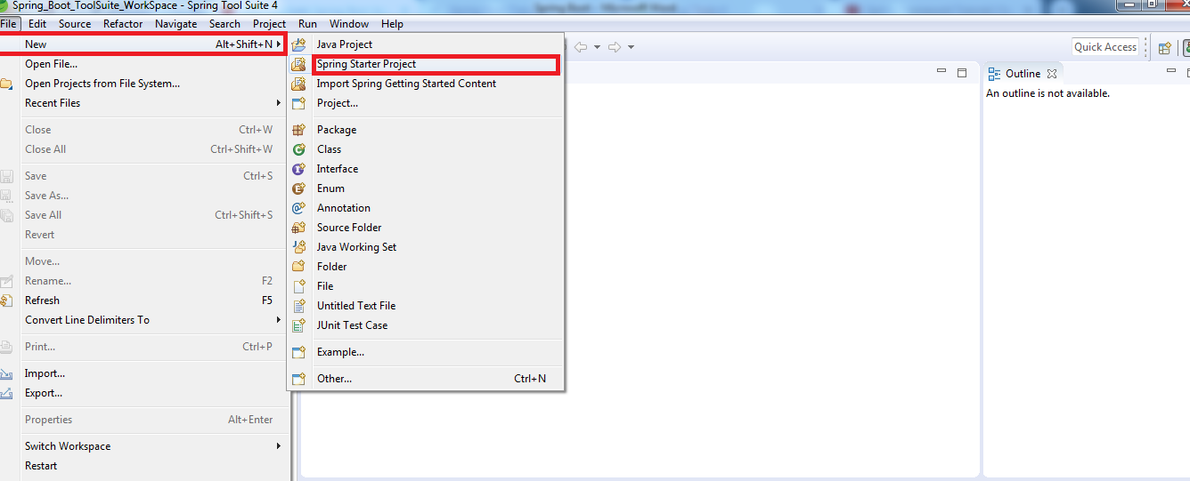

1. Step2:

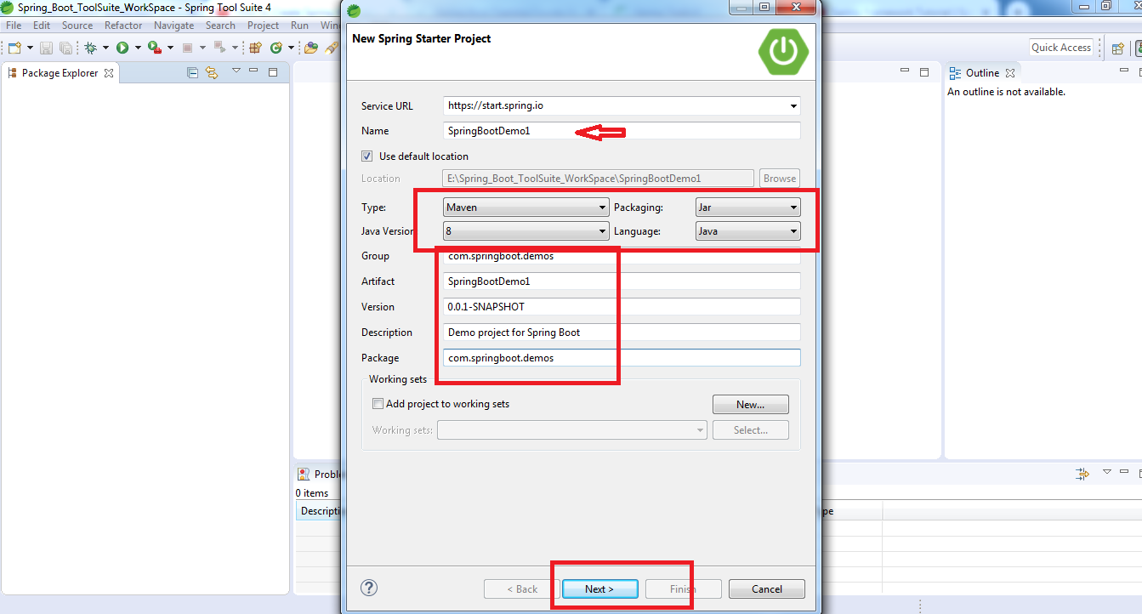

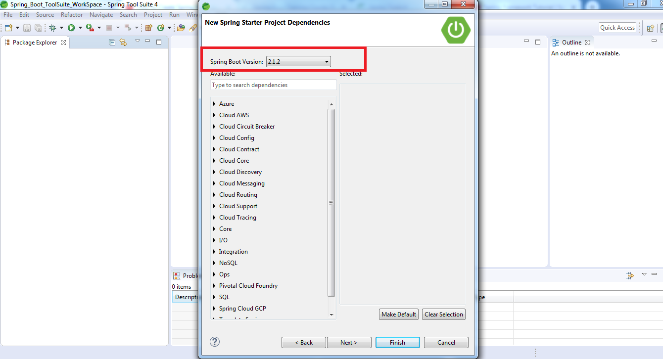

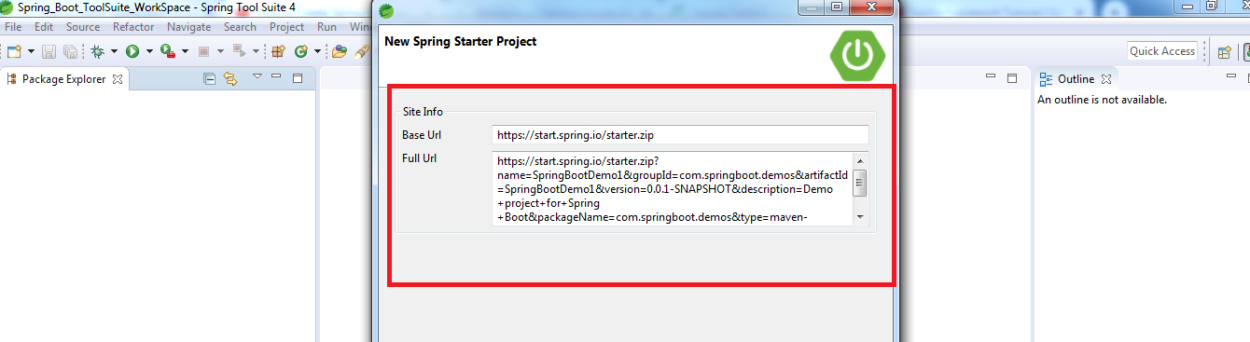

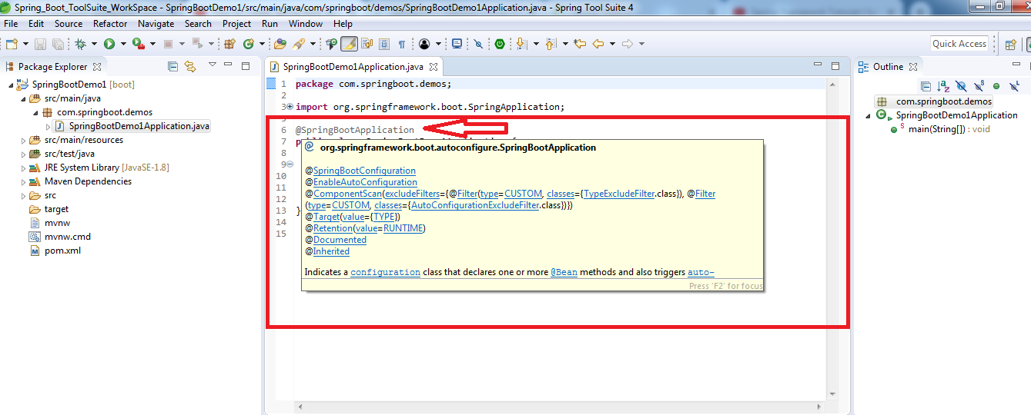

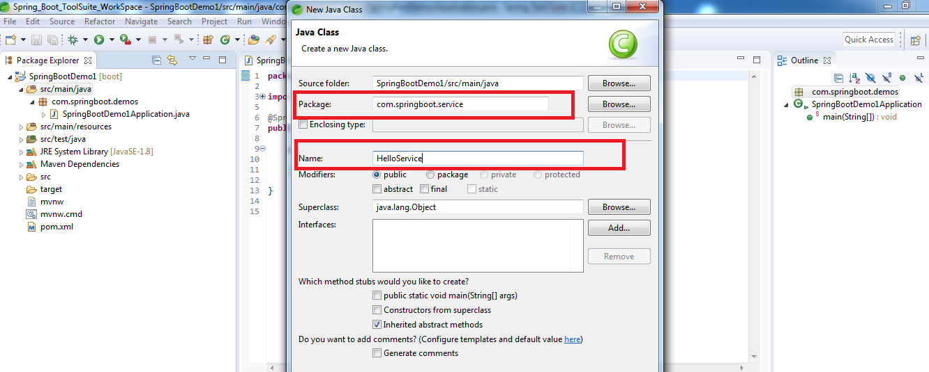

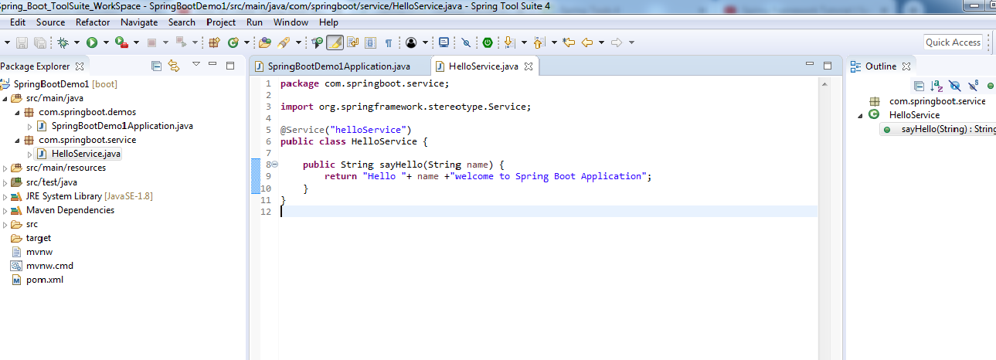

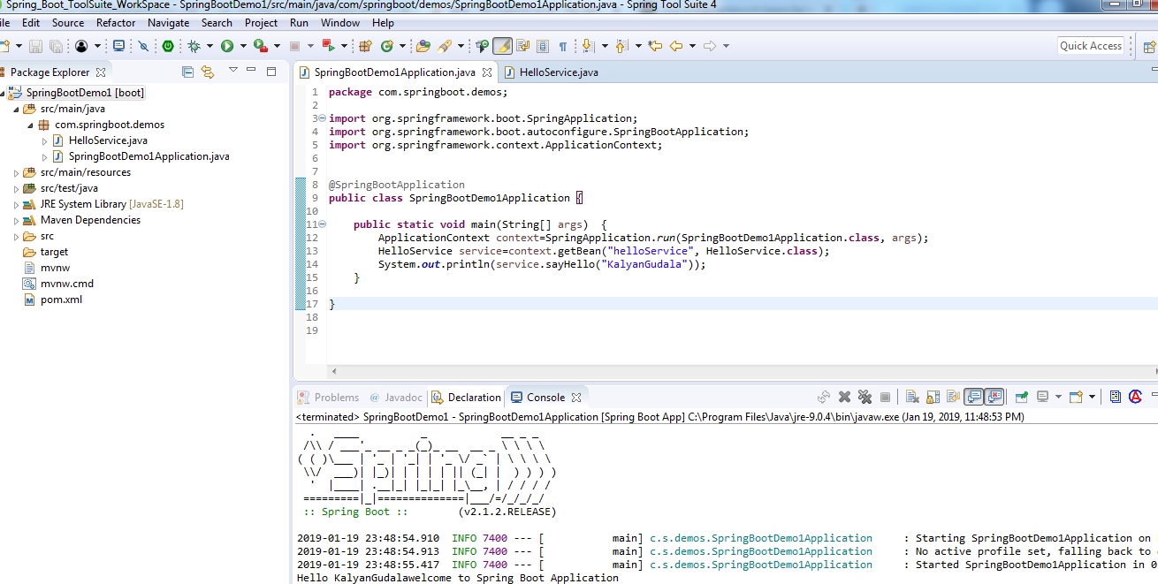

**Spring Boot Application using Rest Controller:**

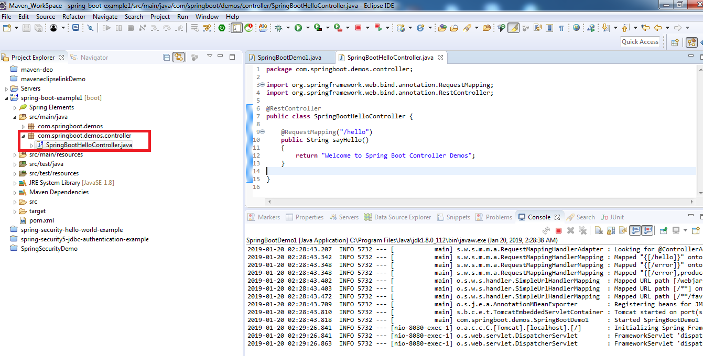

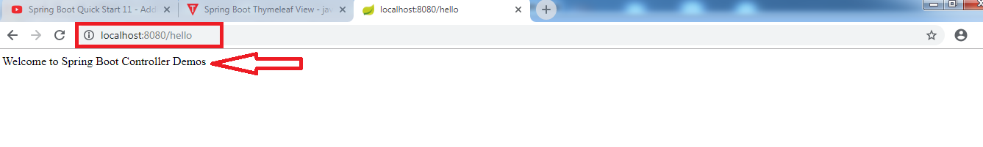

**Spring Boot: Returning Objects from Controller**

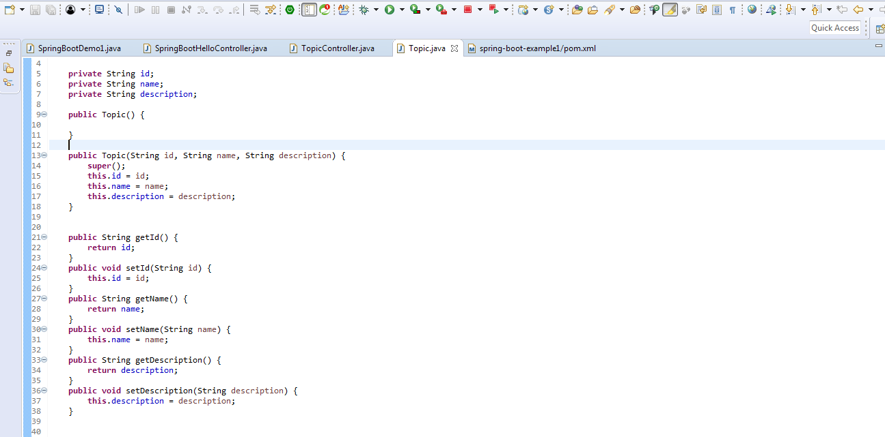

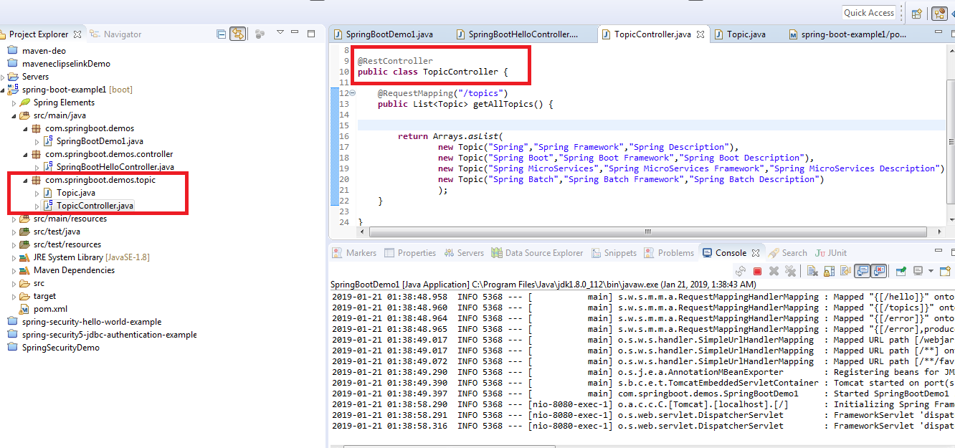

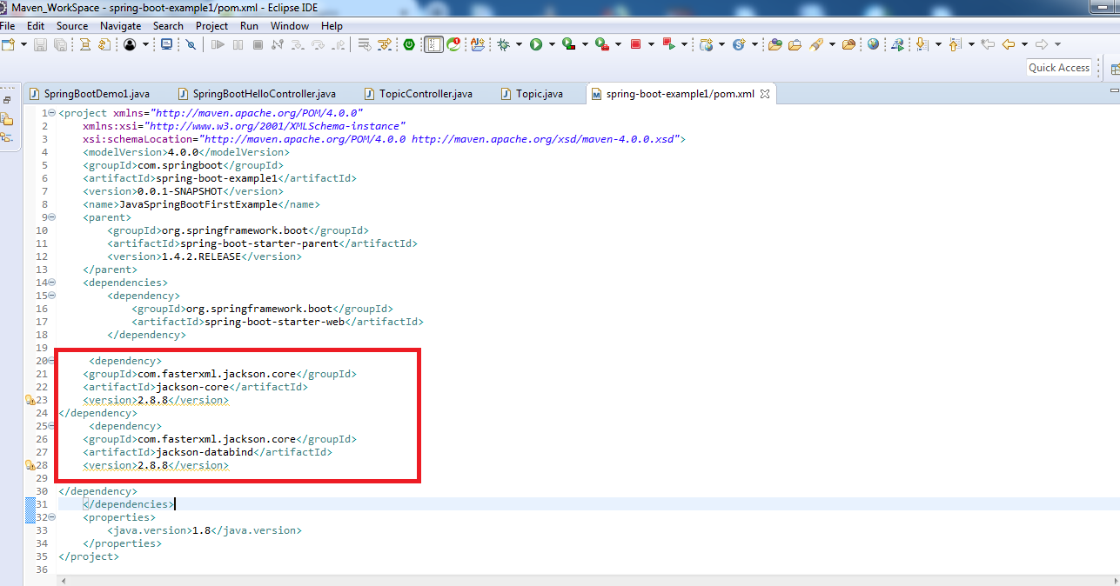

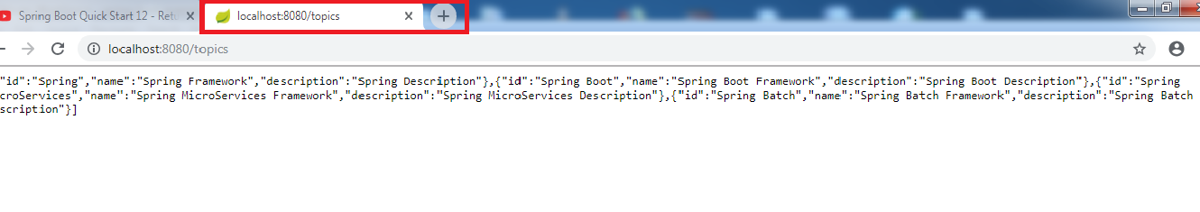

**Note:** If you get port related issues if it’s already running and properly shut down use the following commands:

netstat -ano | findstr :8080

taskkill /pid 5236 /f

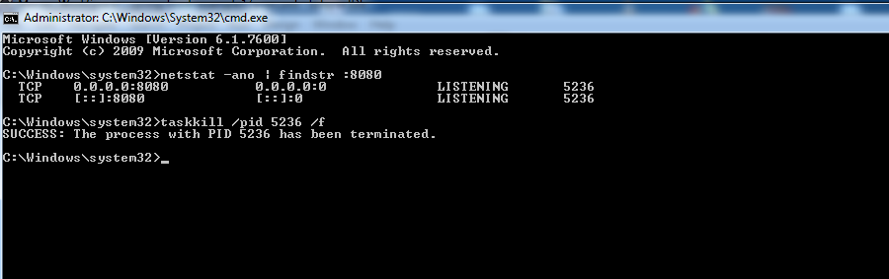

**Bill of Materials:**

This Bill of Materials is that the parent dependency which exists in the pom.xml will automatically update the versions of the required dependencies apart from that we explicitly mention it.

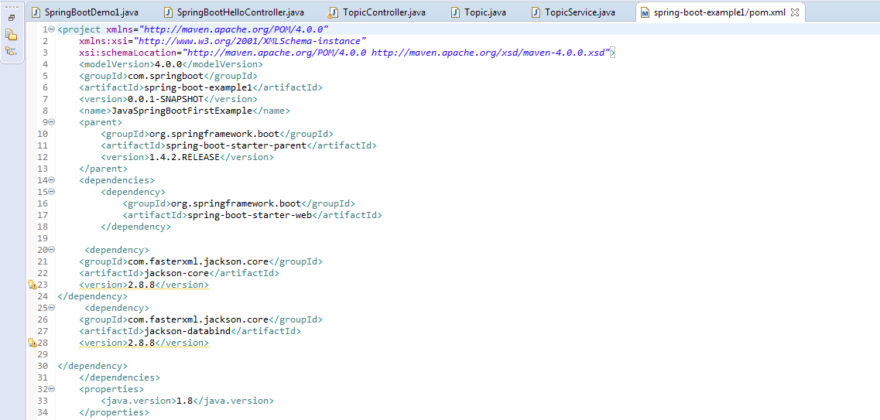

**Embeded tomcat Server:**

* *Convenience.*
* *Servlet Container config is now application config.*
* *Standalone application.*
* *Useful for microservice Architecture.*

**Spring MVC Controller:**

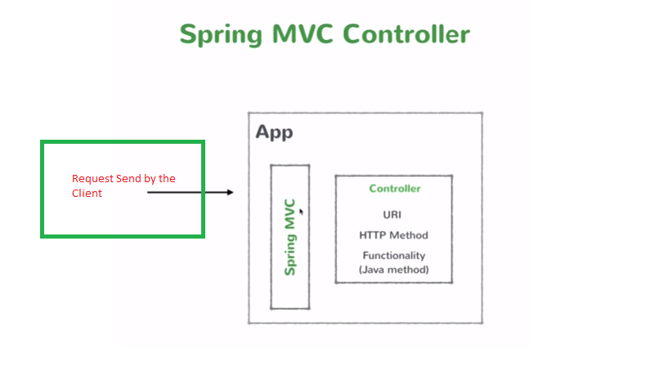

**The REST API we'll build :**

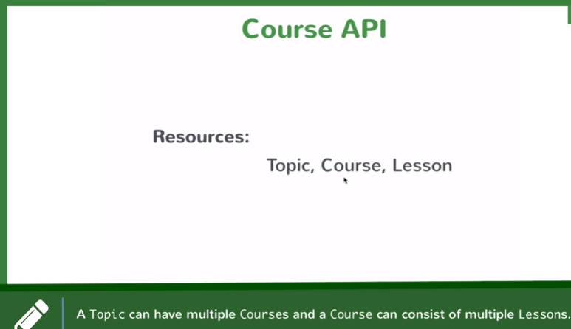

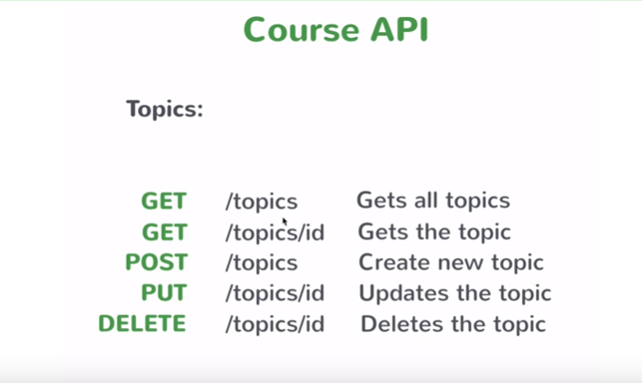

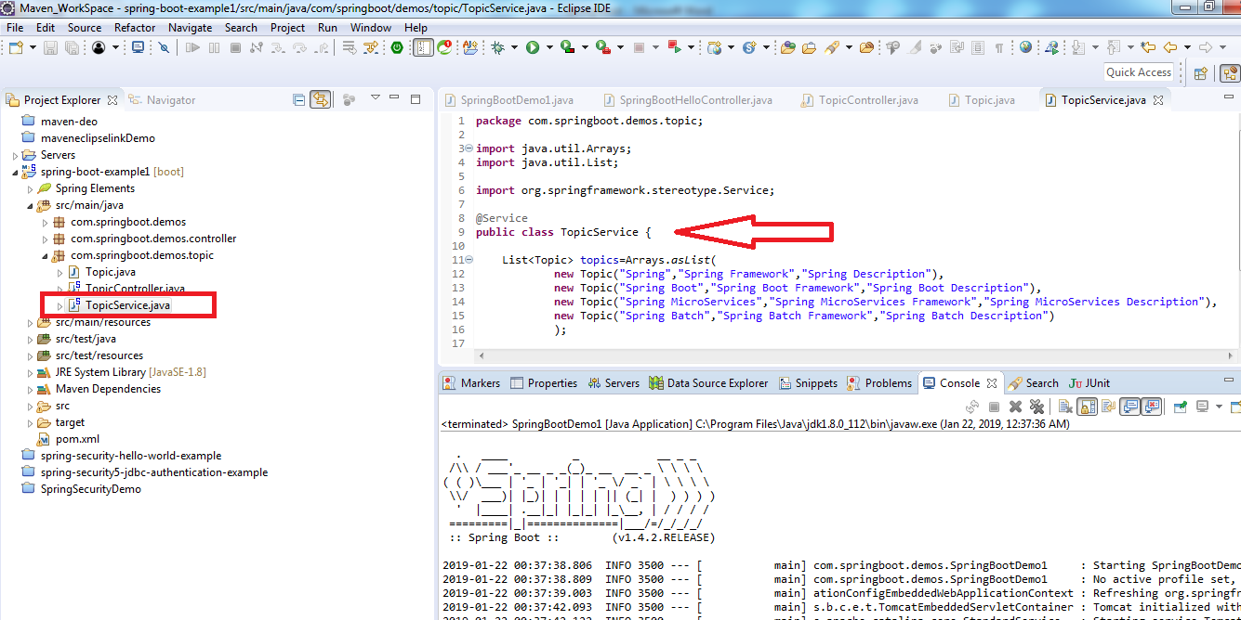

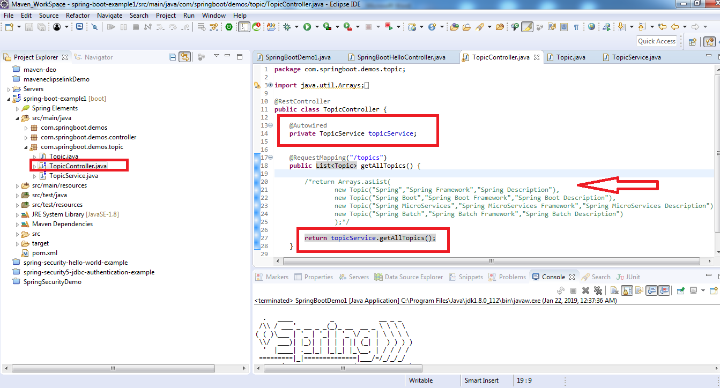

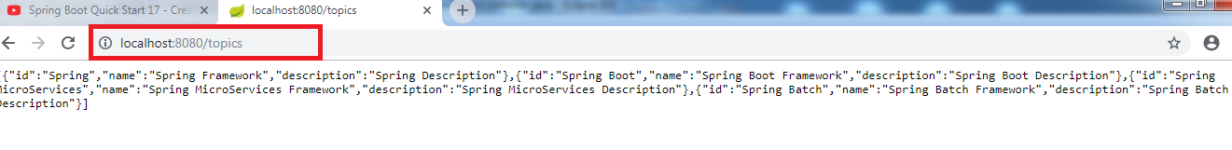

**/GET Method to get the Topic:**

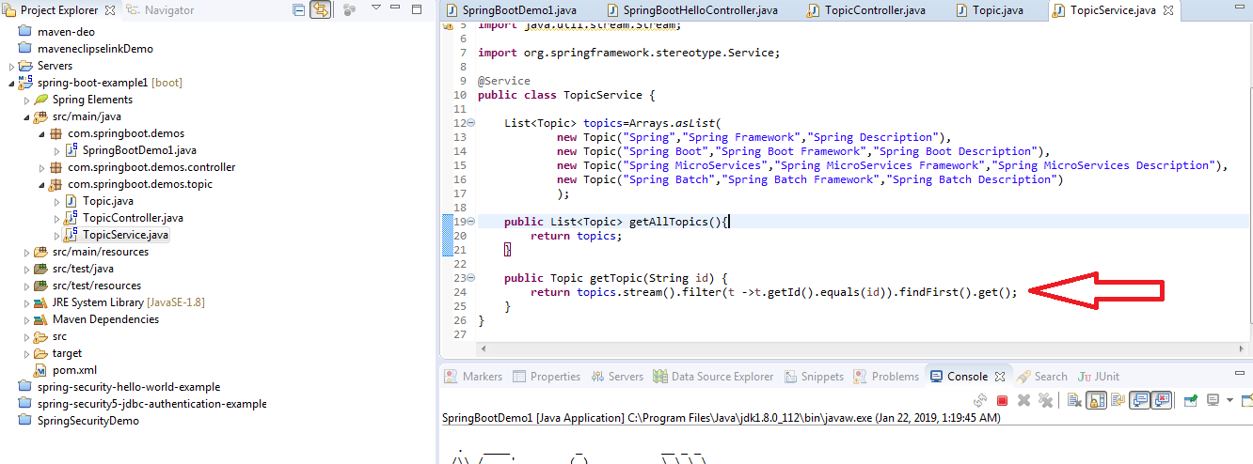

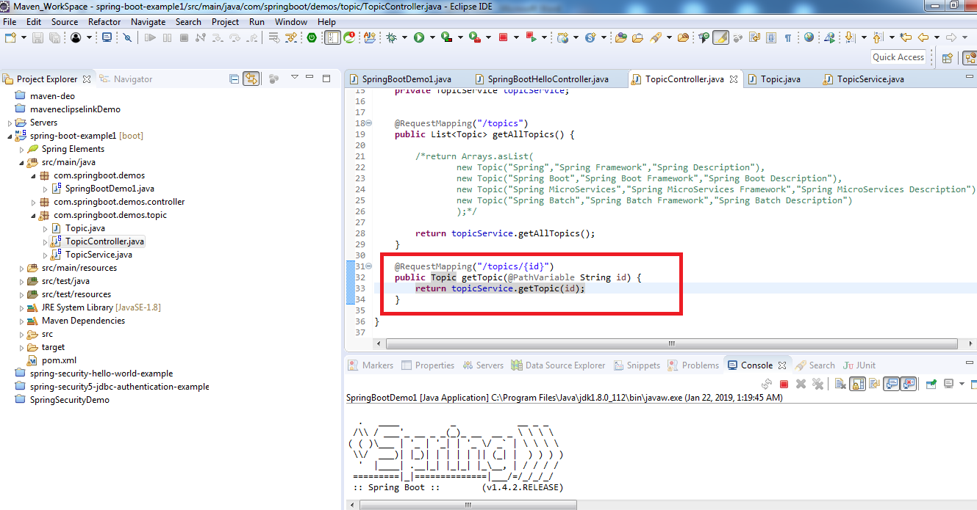

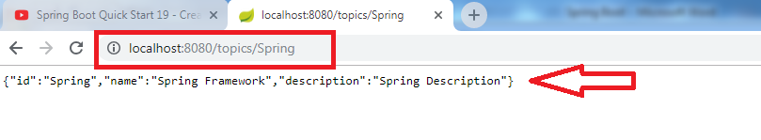

**/POST & /PUT Method to Add and Update the Topic:**

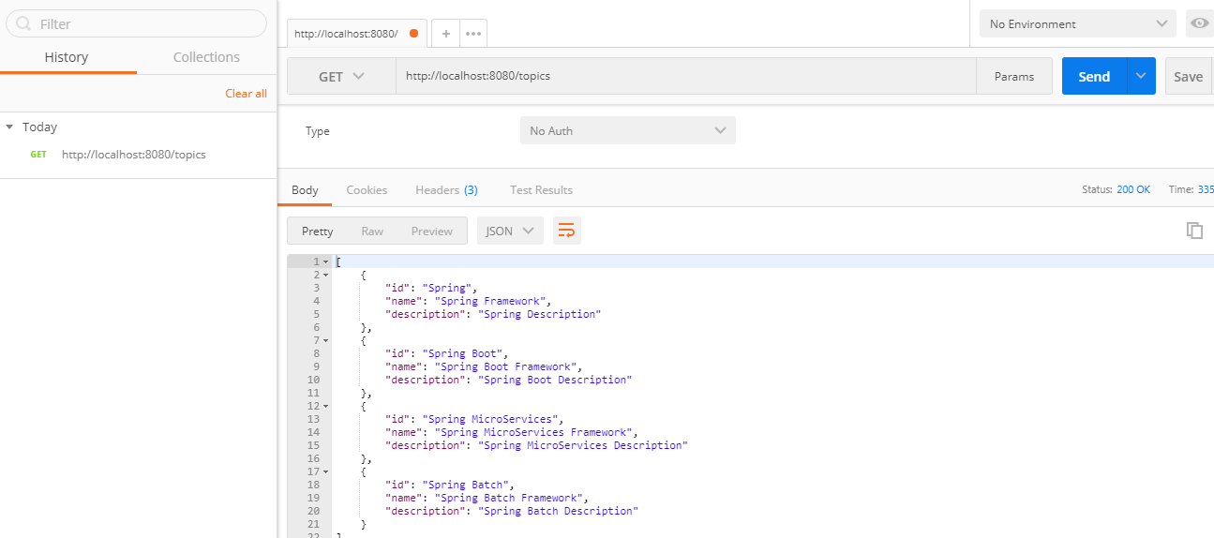

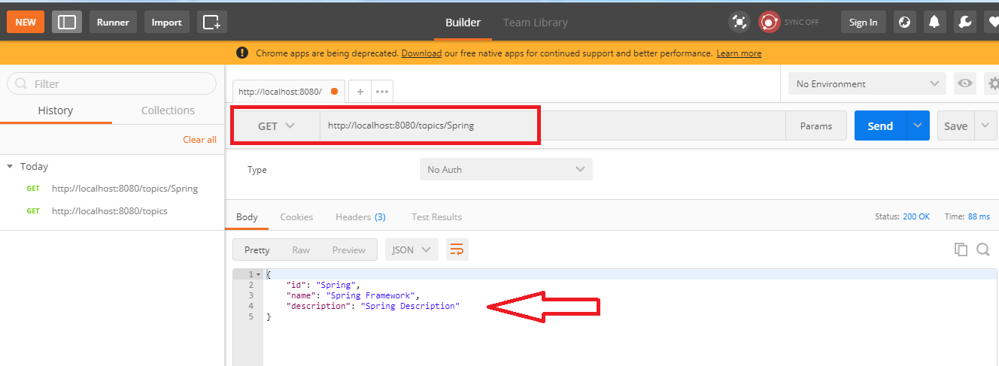

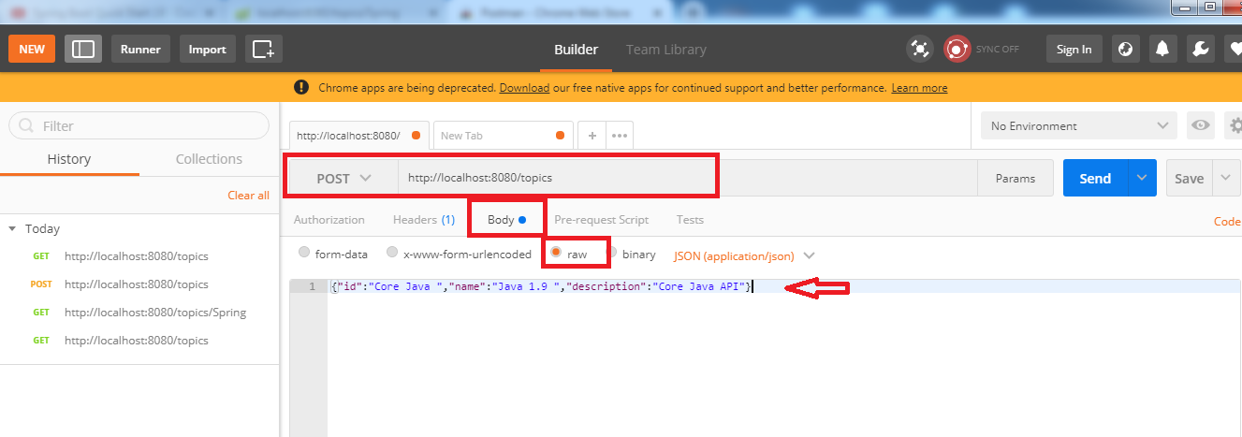

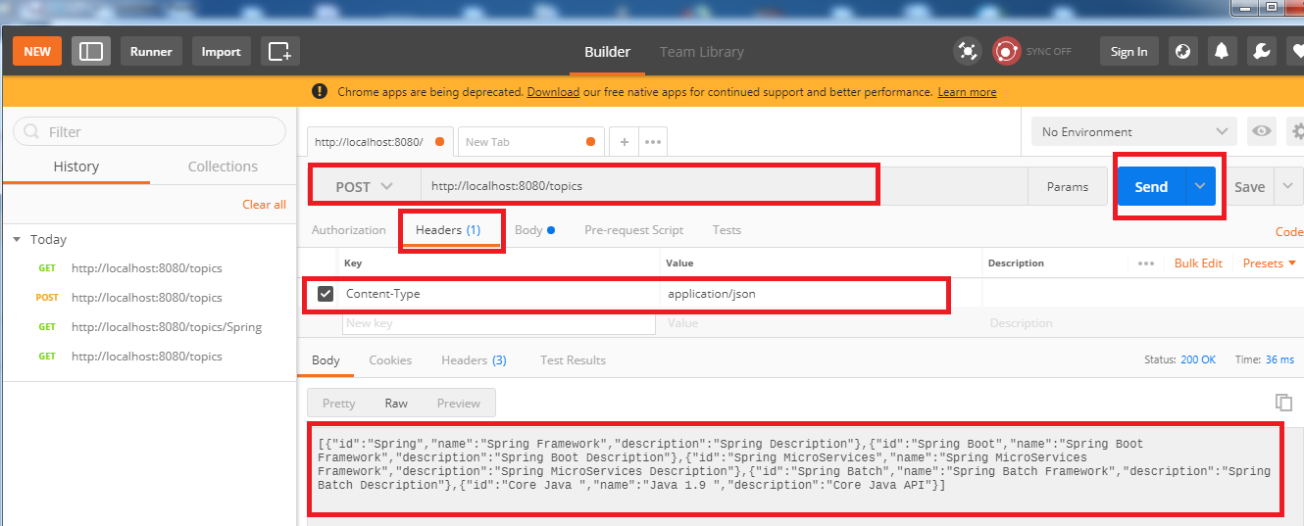

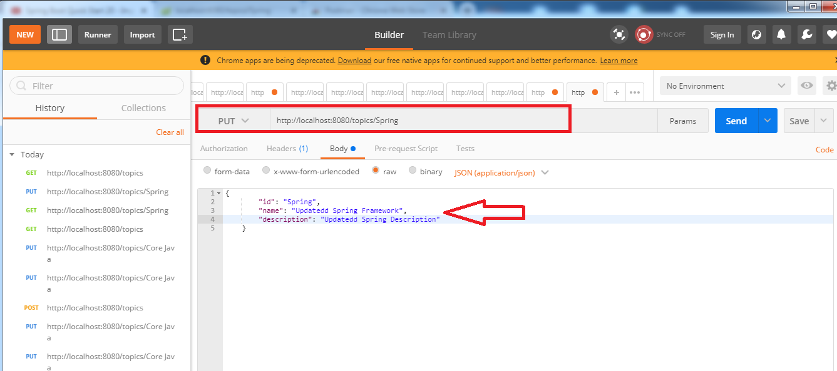

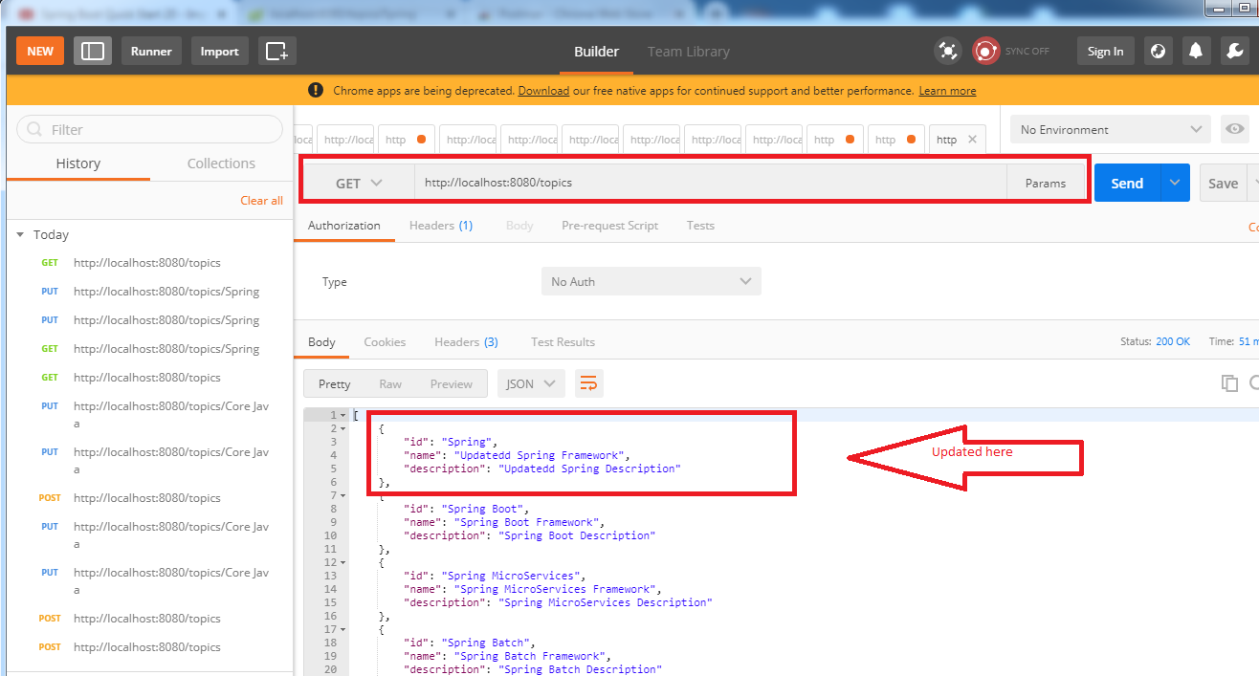

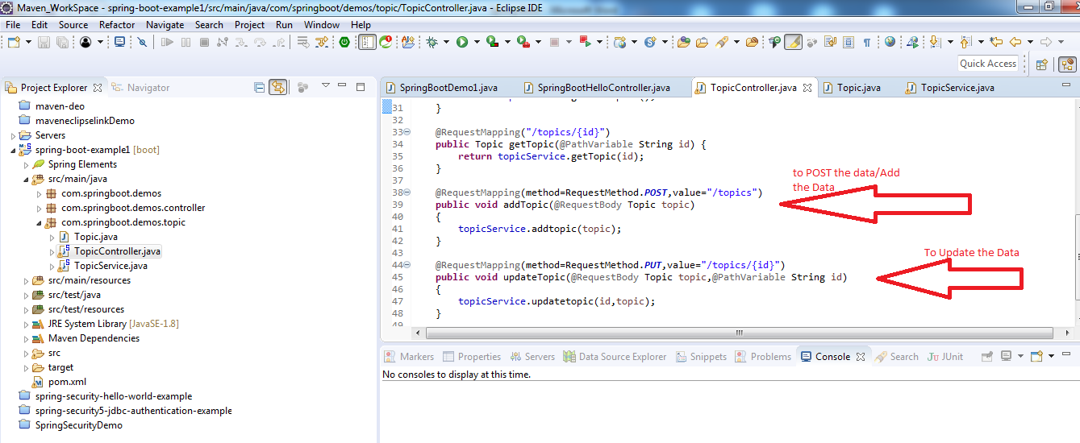

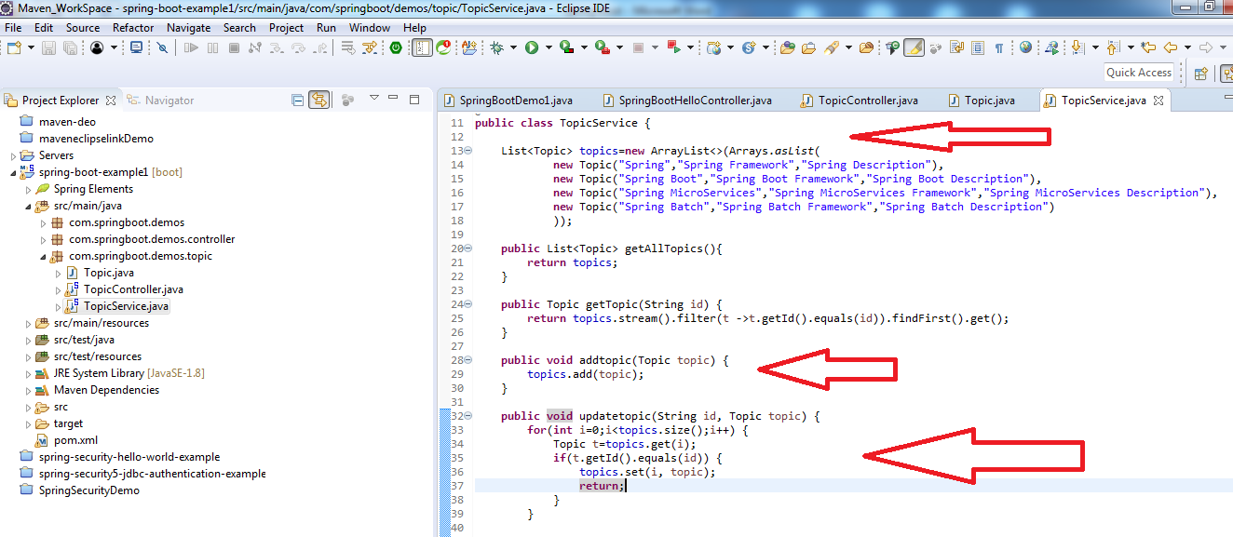

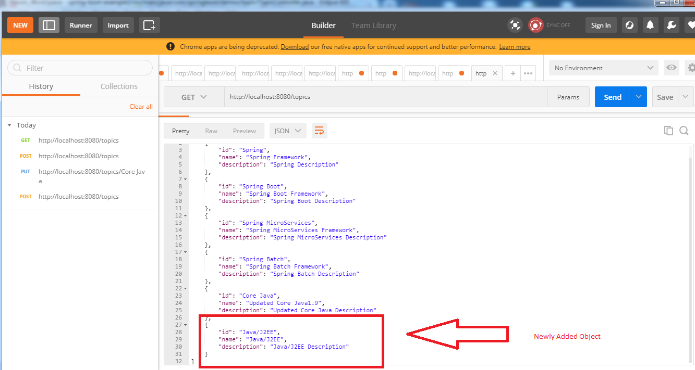

**/Delete Method to delete the Topic:**

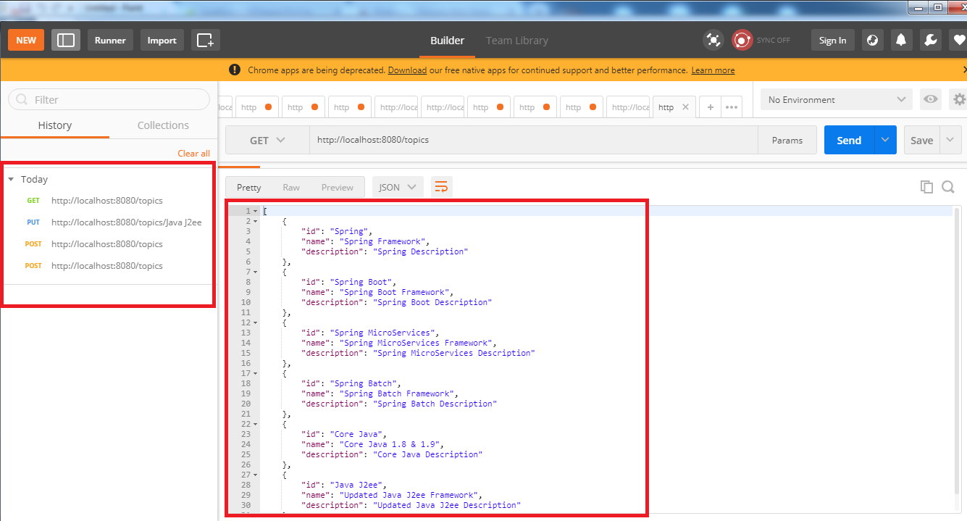

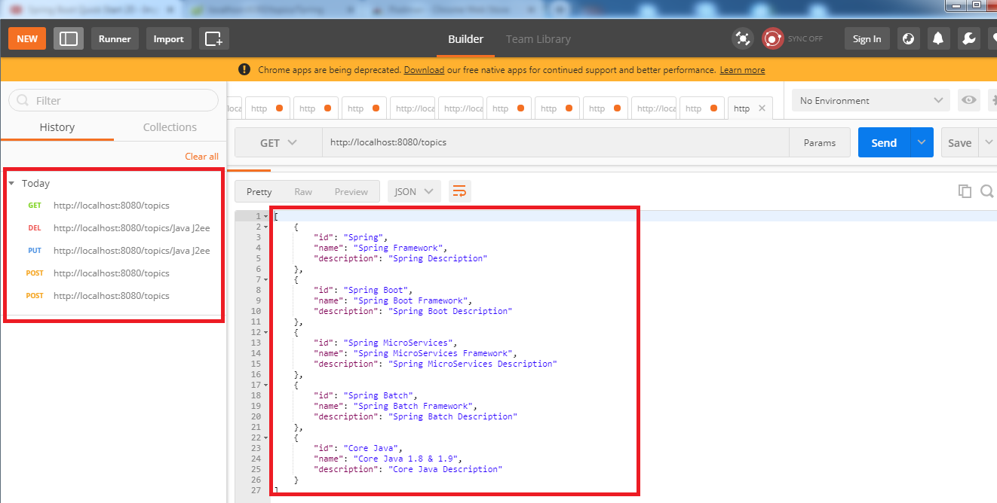

**Various ways of Starting a Spring Boot App:**

* *Spring Initializer*
* *Spring Boot CLI*
* *STS IDE*
* *Configuration*

**Spring Initializer:**

**Step1:** Login to the following site: <https://start.spring.io/>

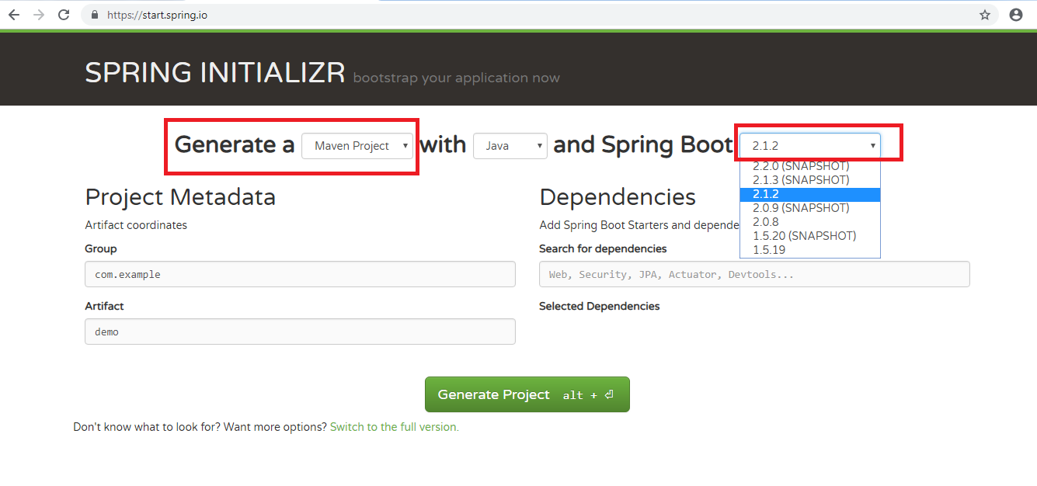

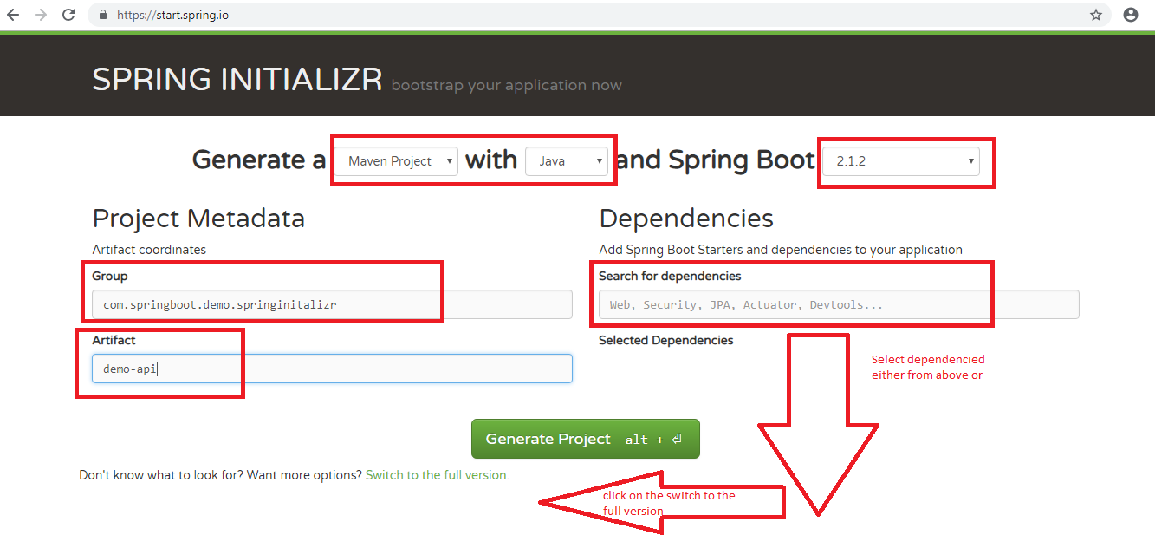

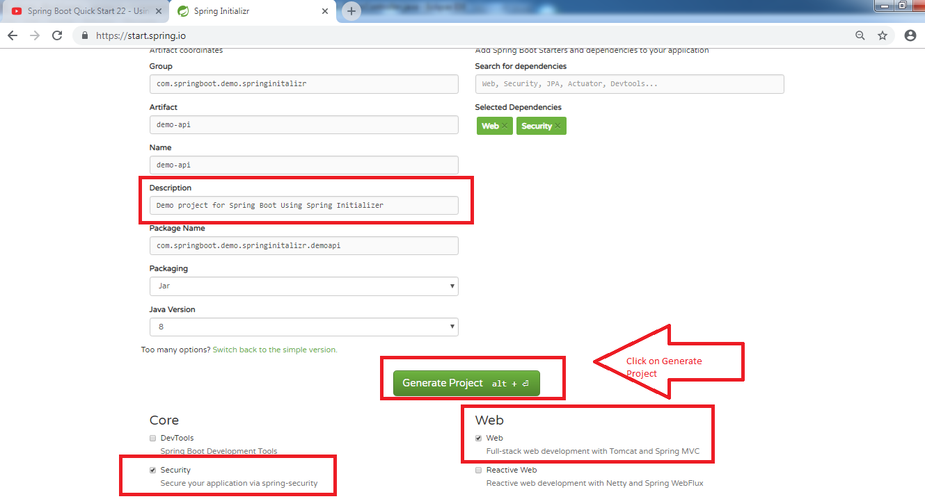

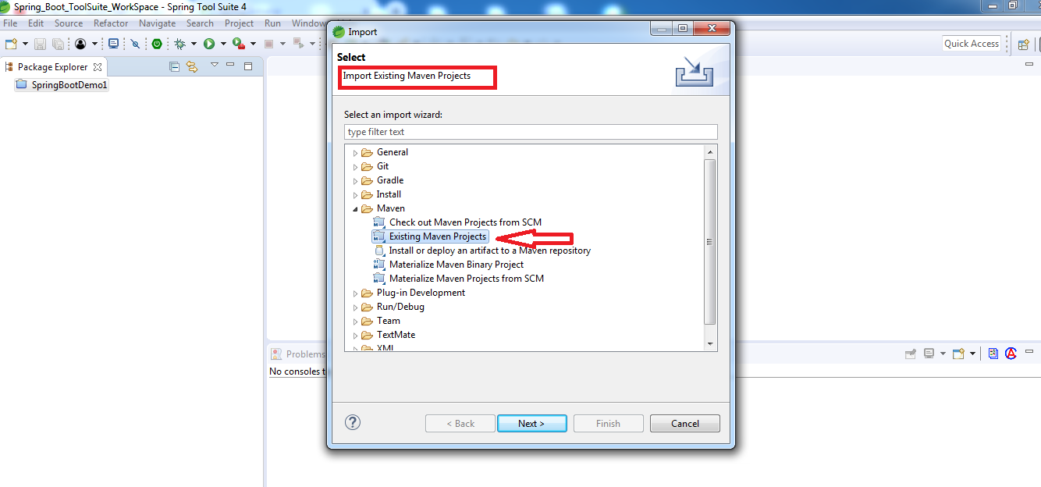

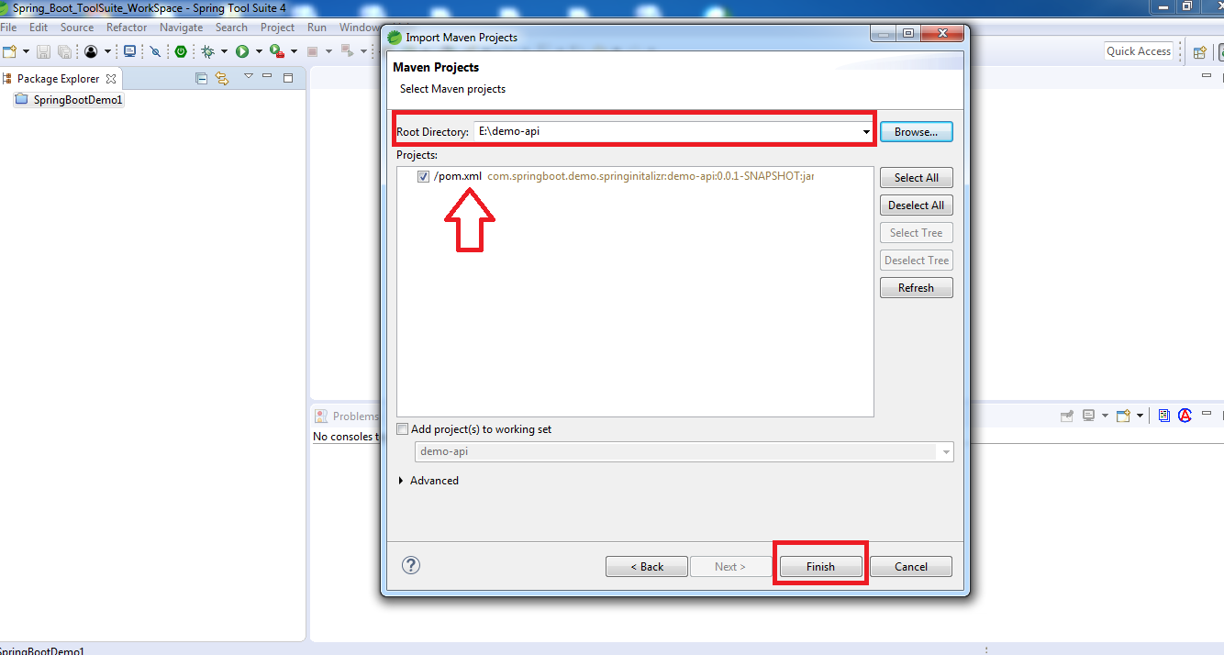

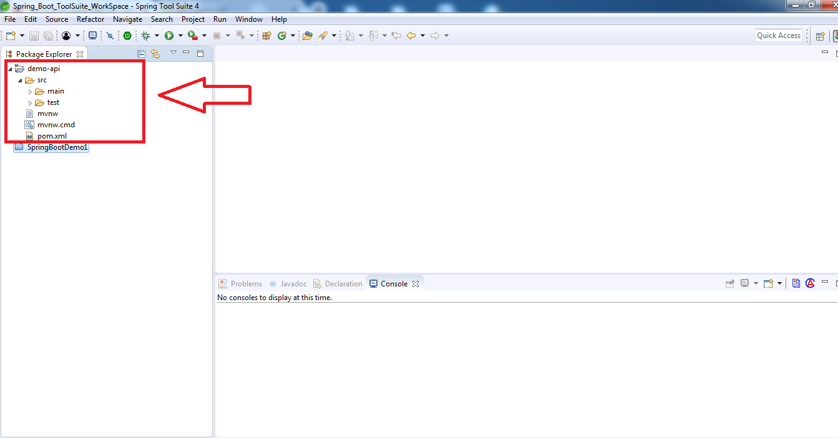

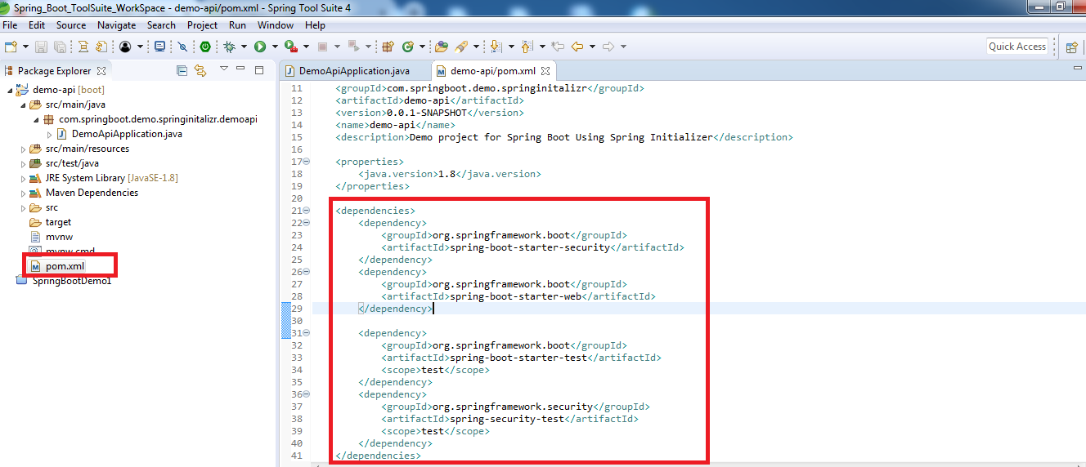

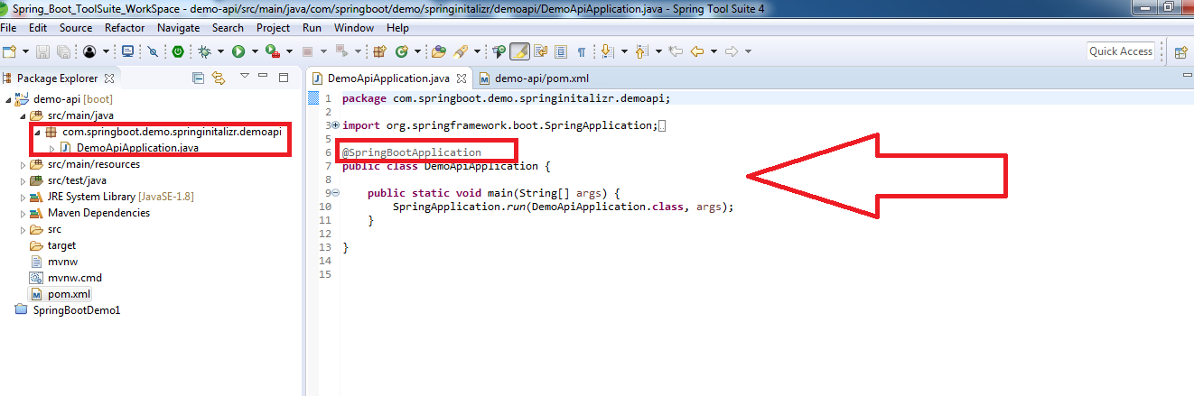

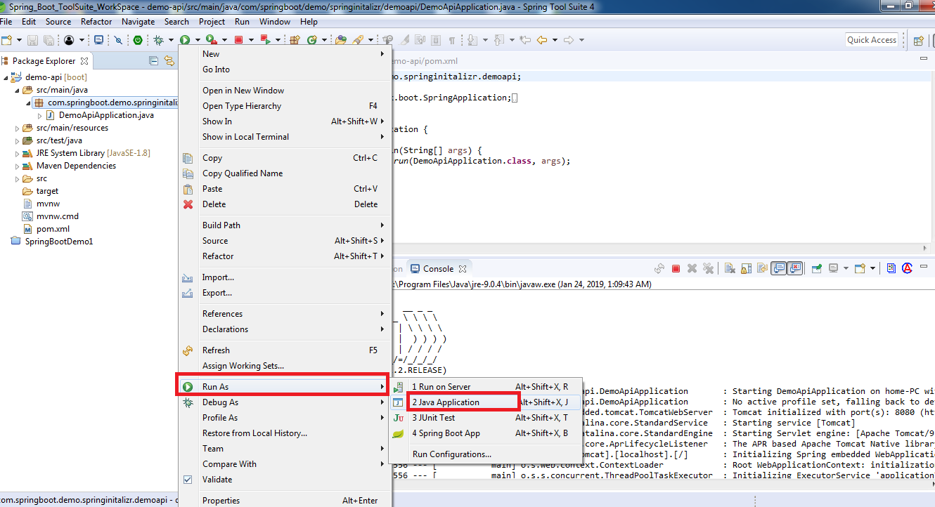

**Spring Boot CLI:**

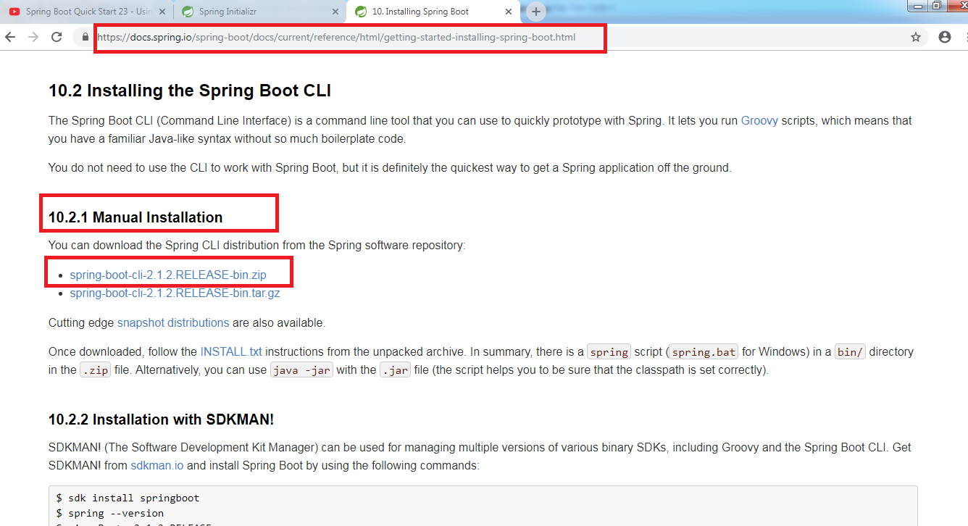

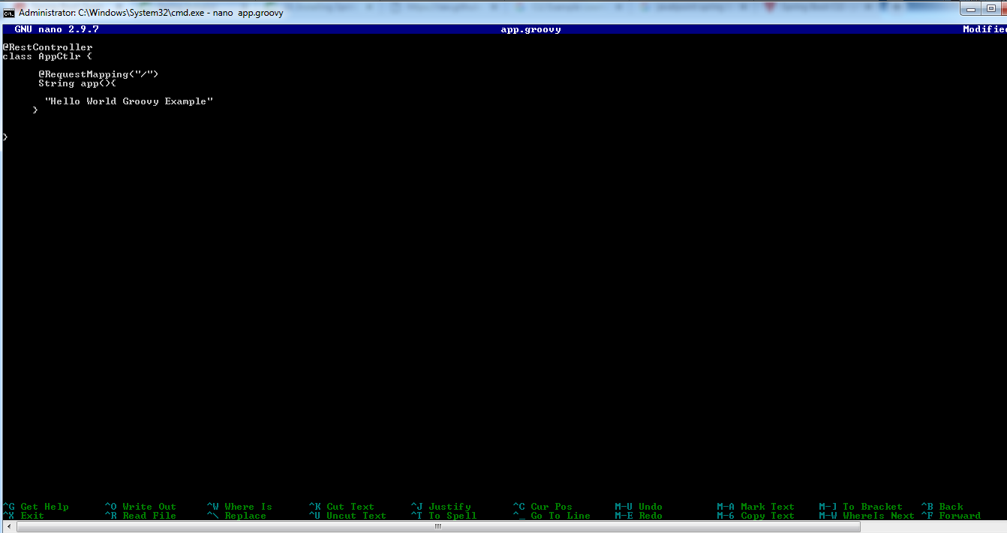

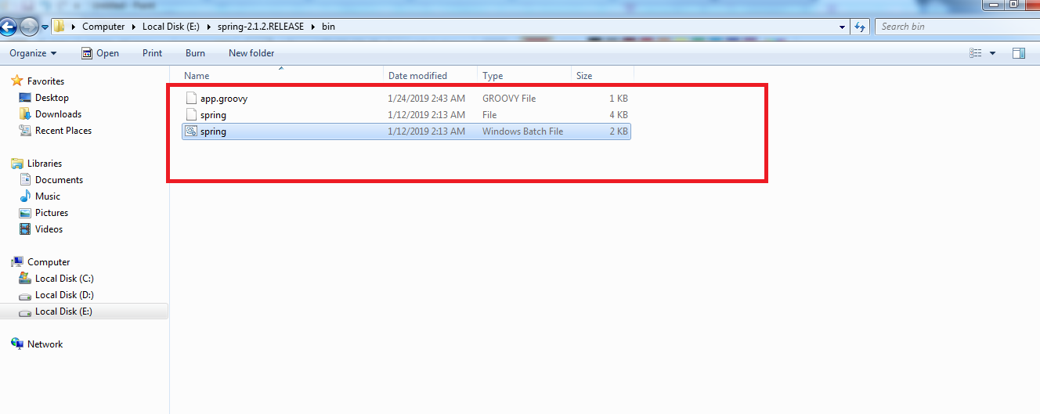

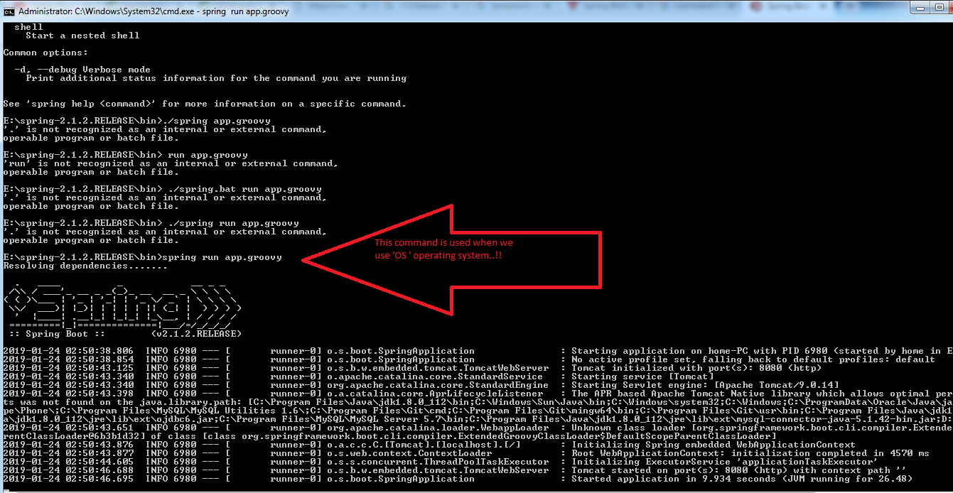

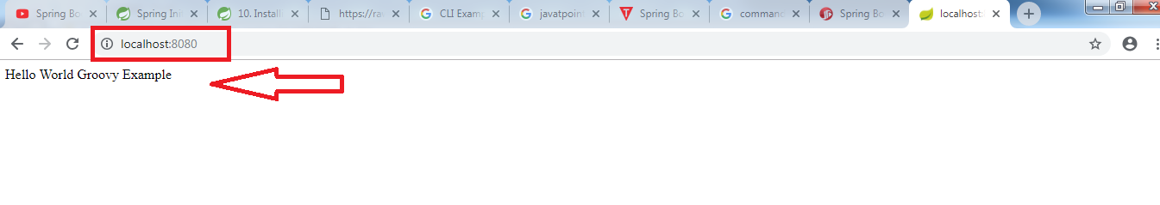

**Spring Boot Using application properties:**

<https://docs.spring.io/spring-boot/docs/current/reference/html/common-application-properties.html>

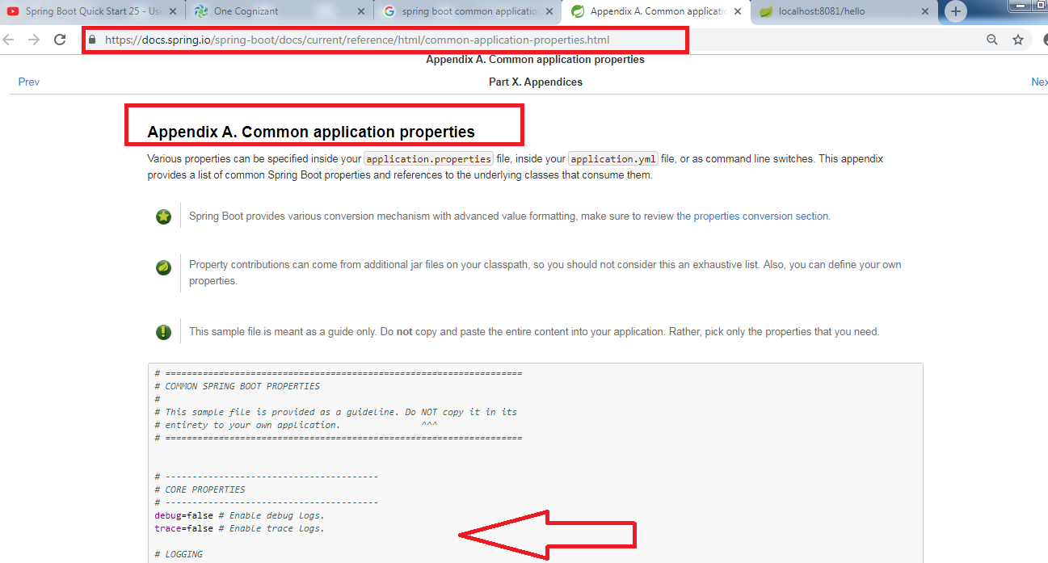

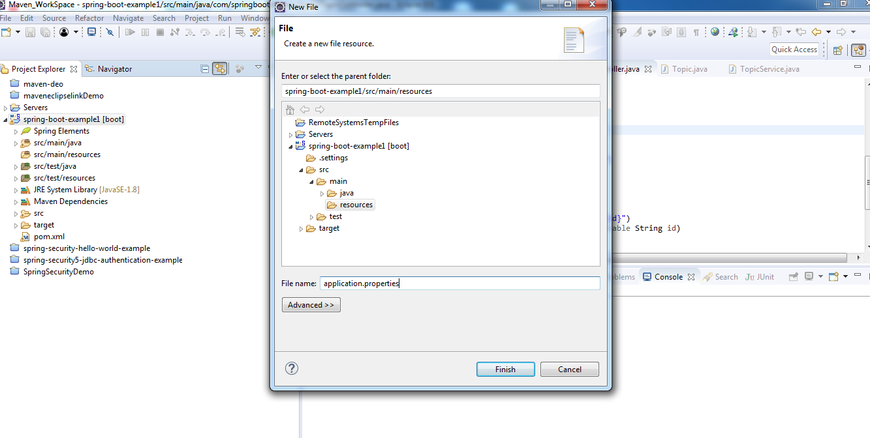

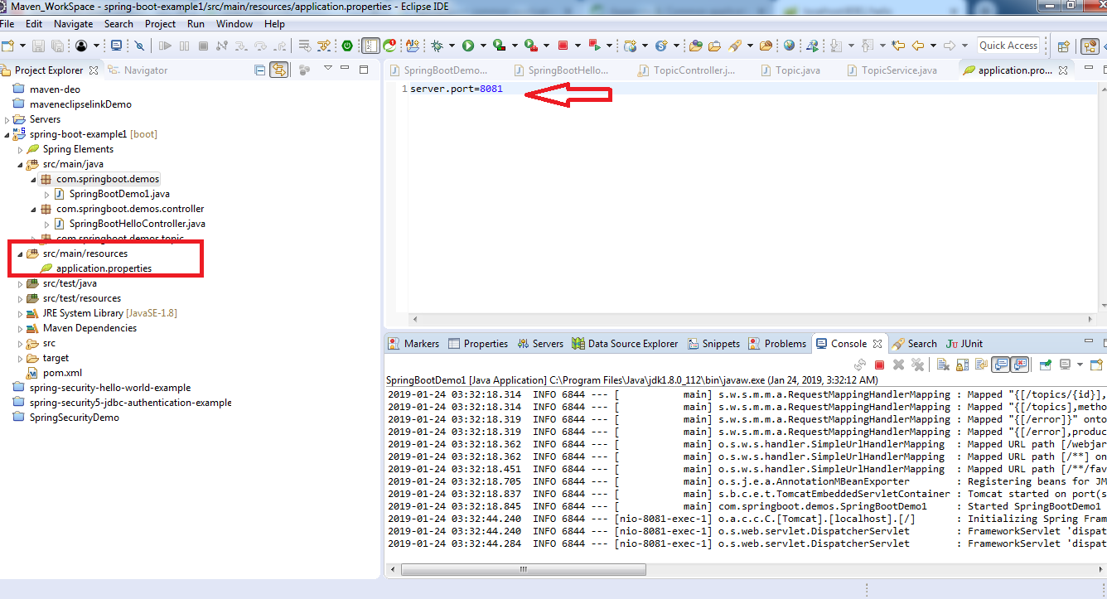

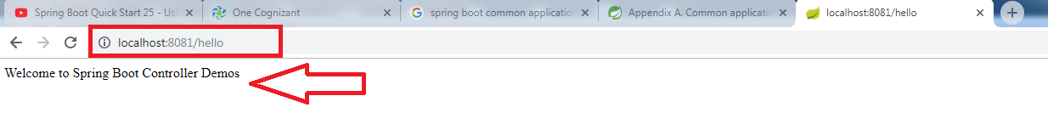

**Spring Boot Using JPA:**

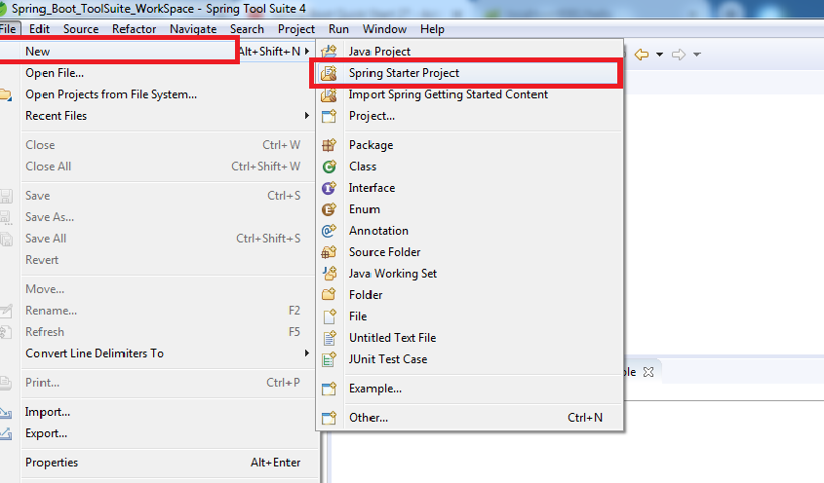

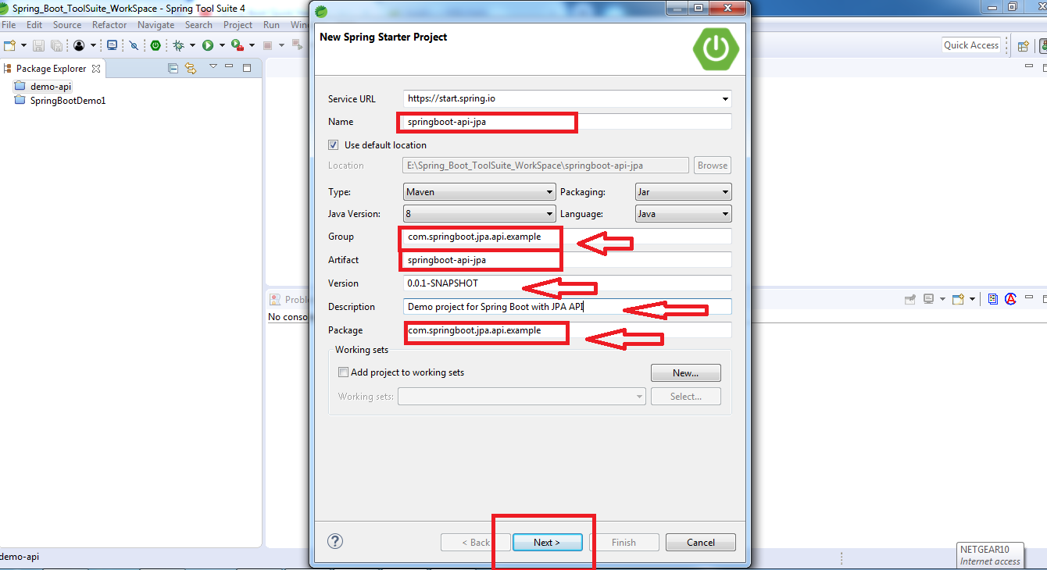

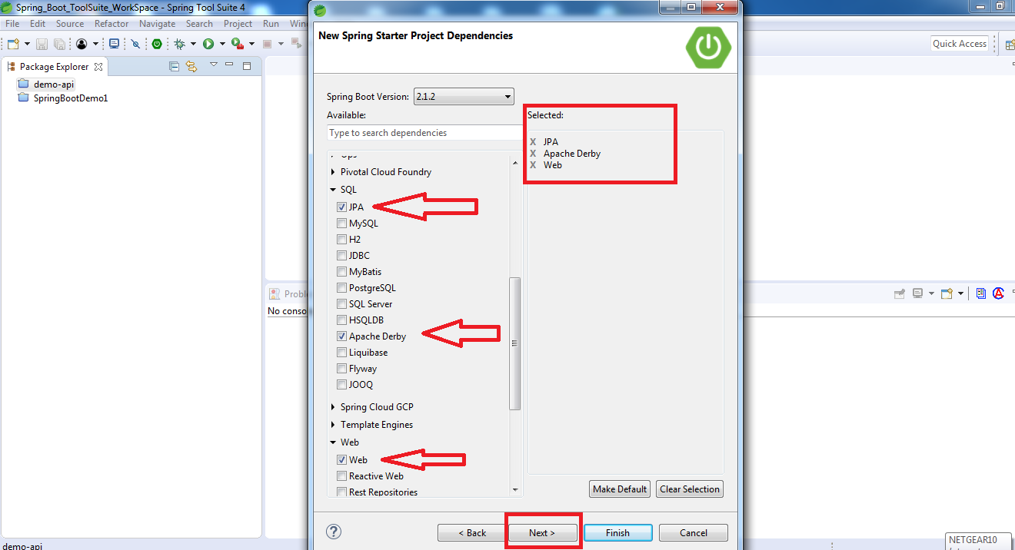

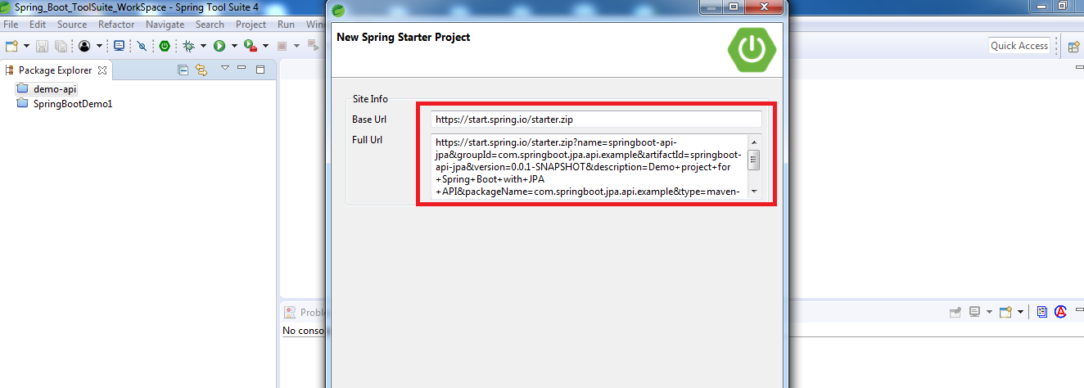

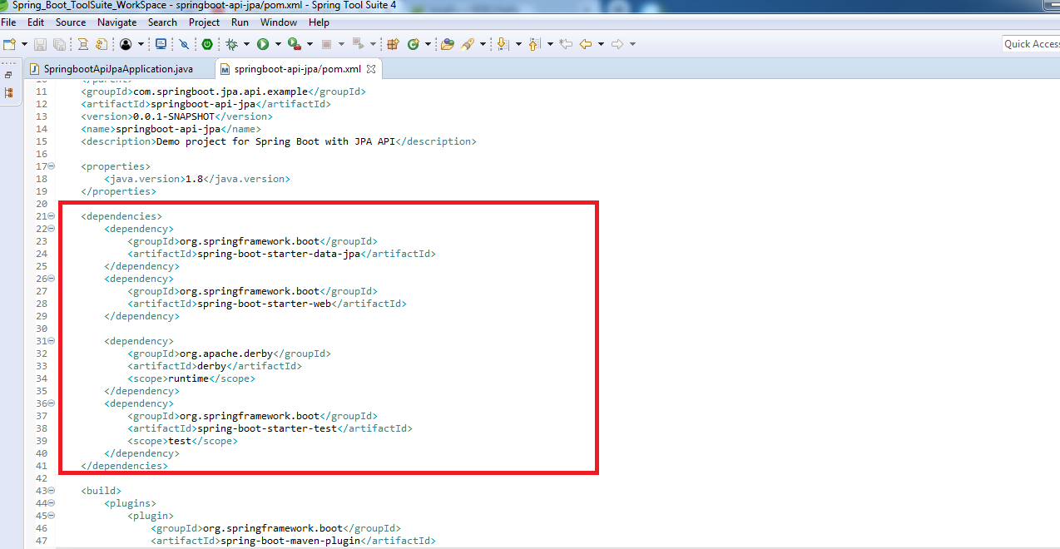

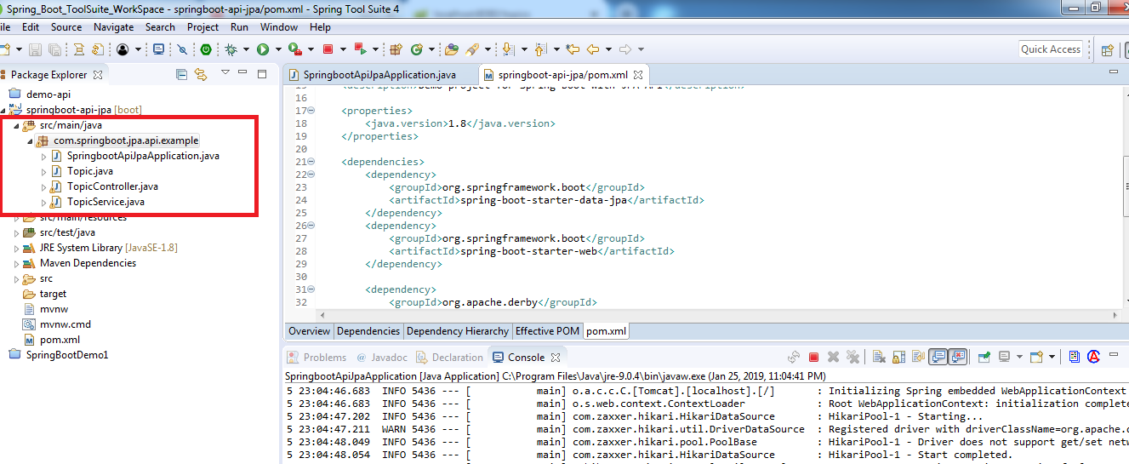

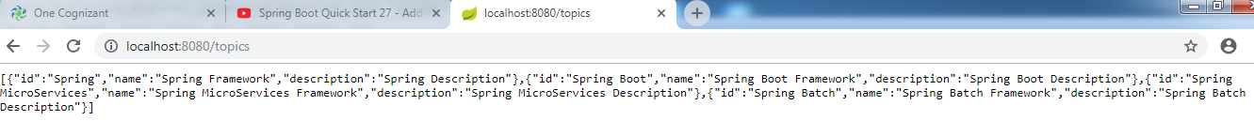

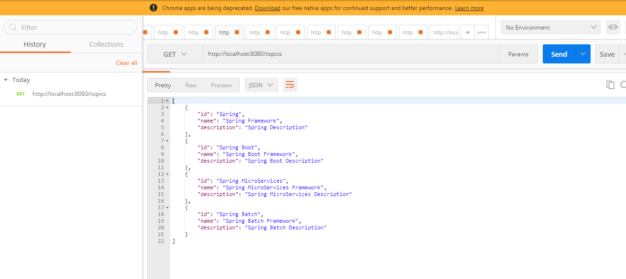

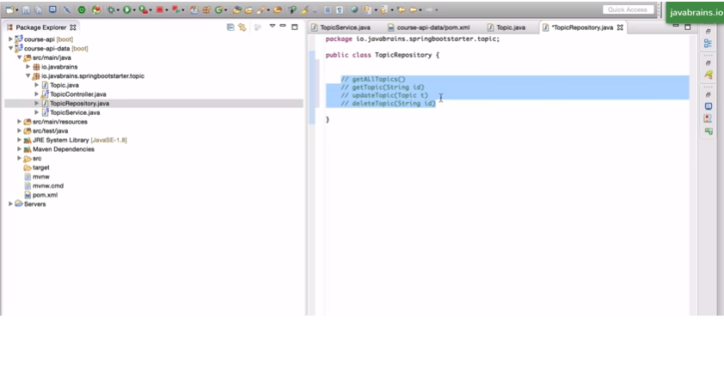

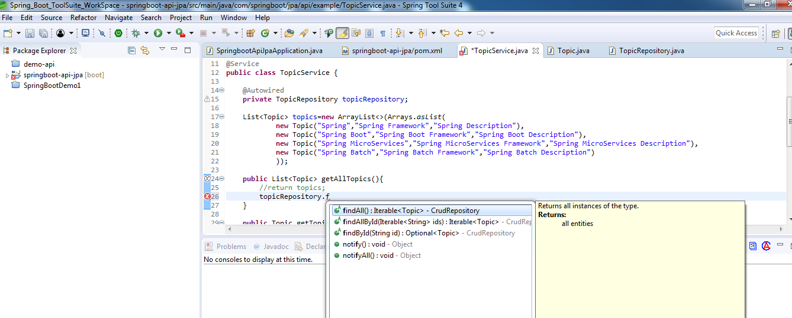

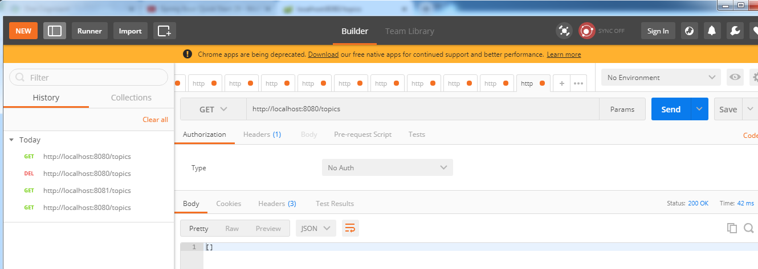

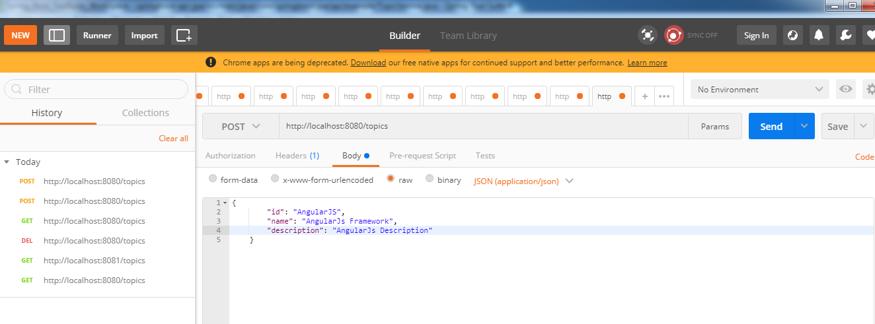

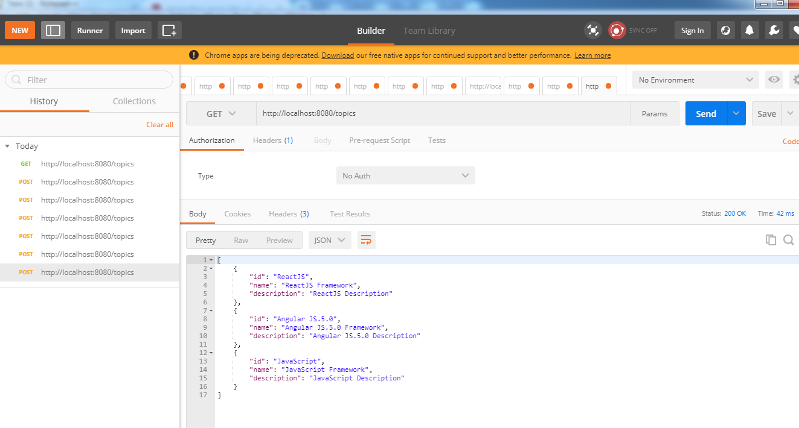

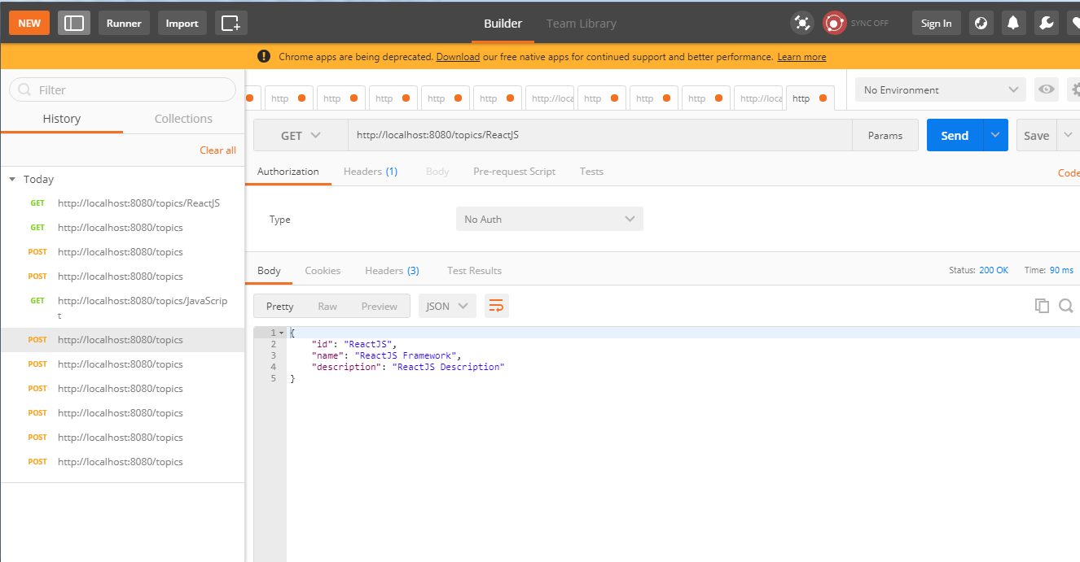

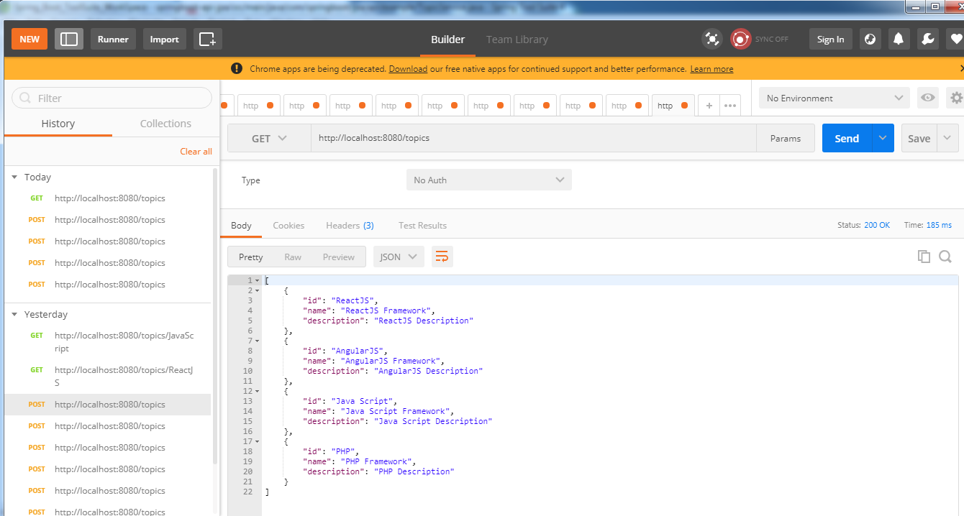

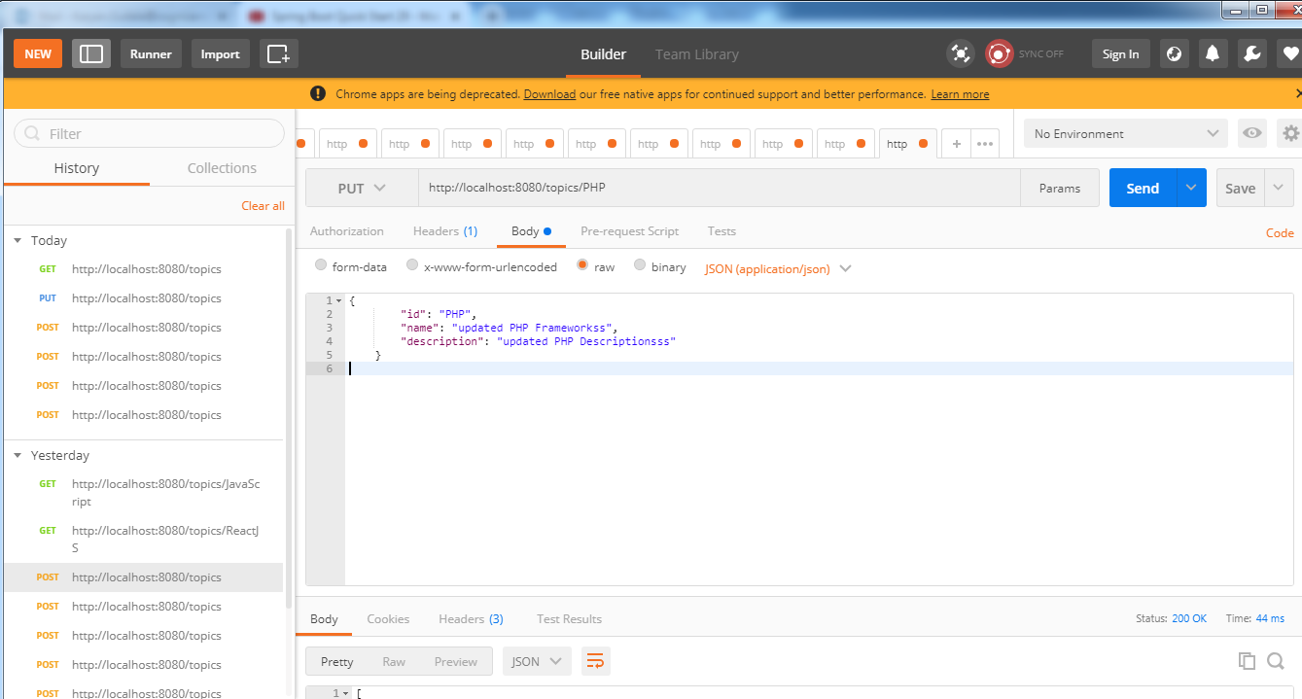

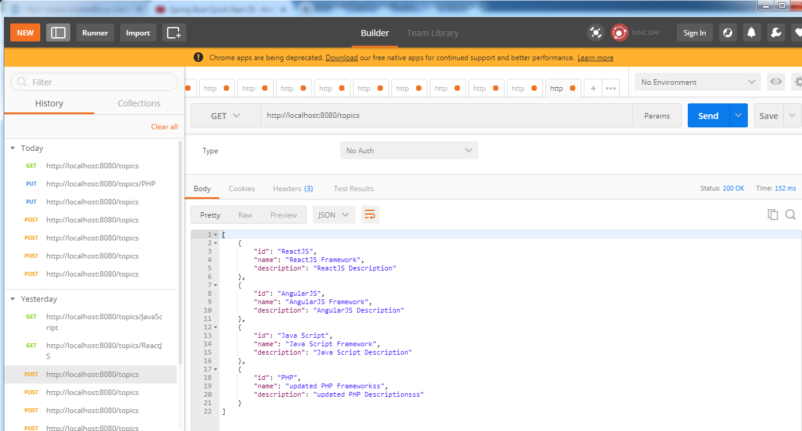

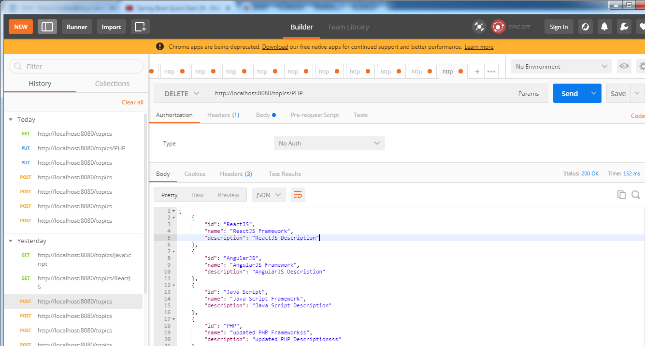

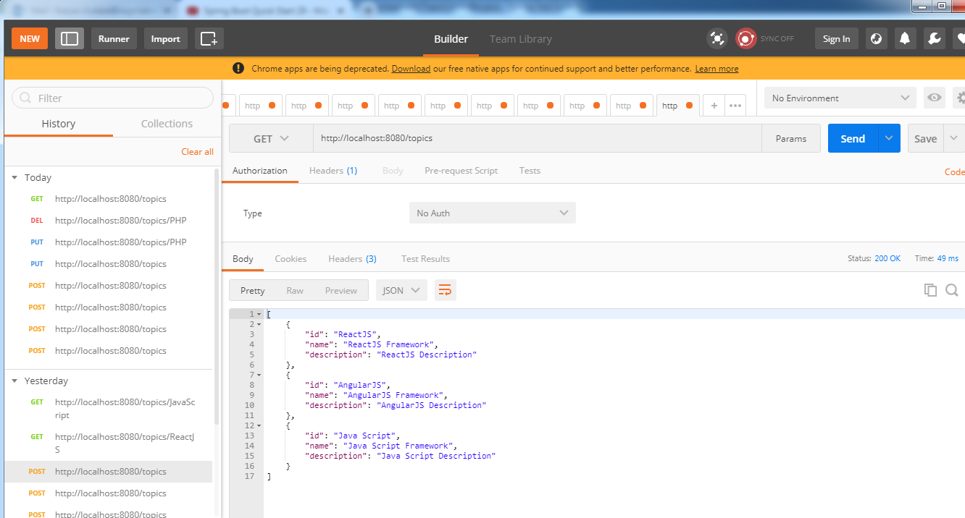

**Adding Course APIs**

**Topic:**

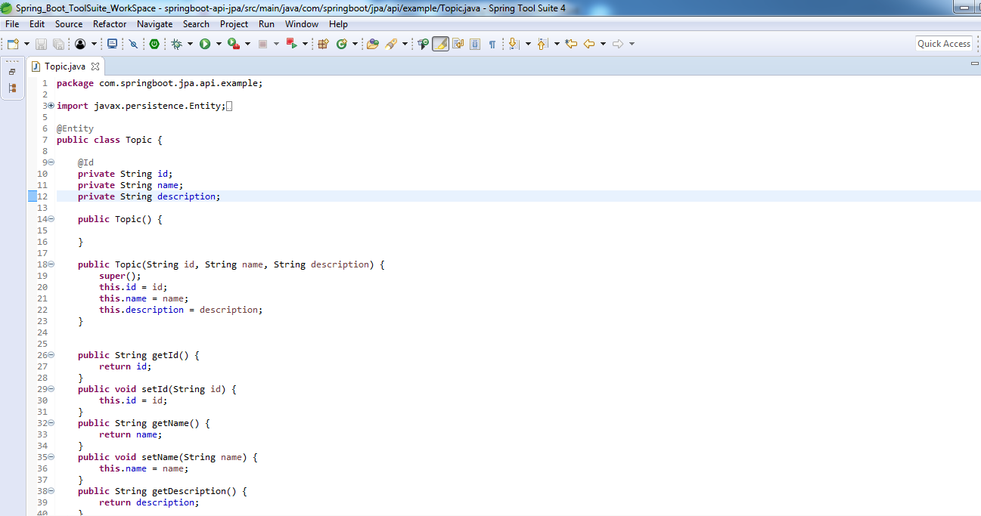

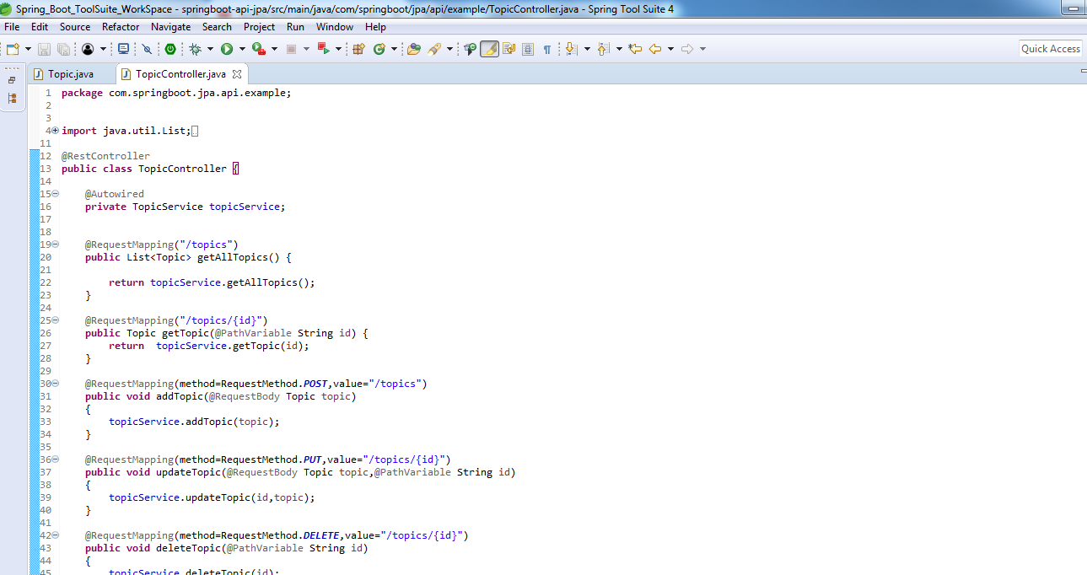

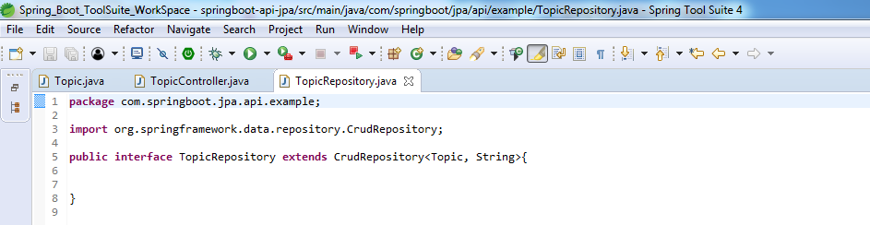

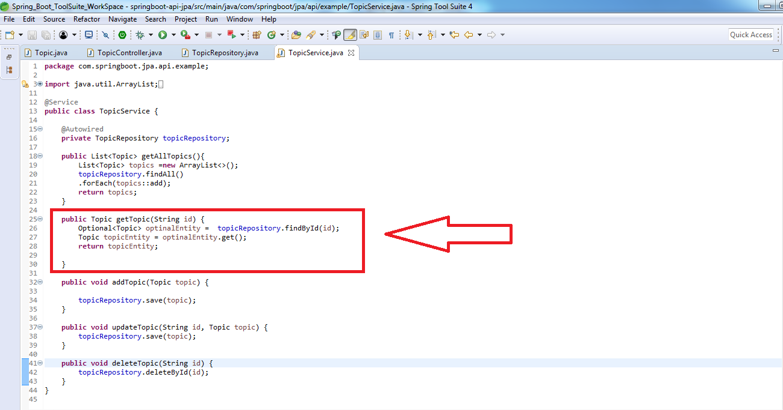

**Course:**

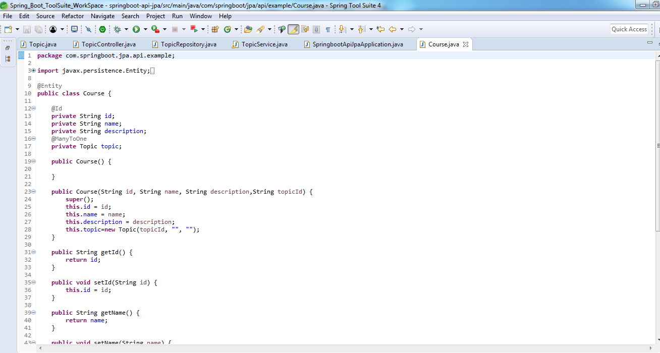

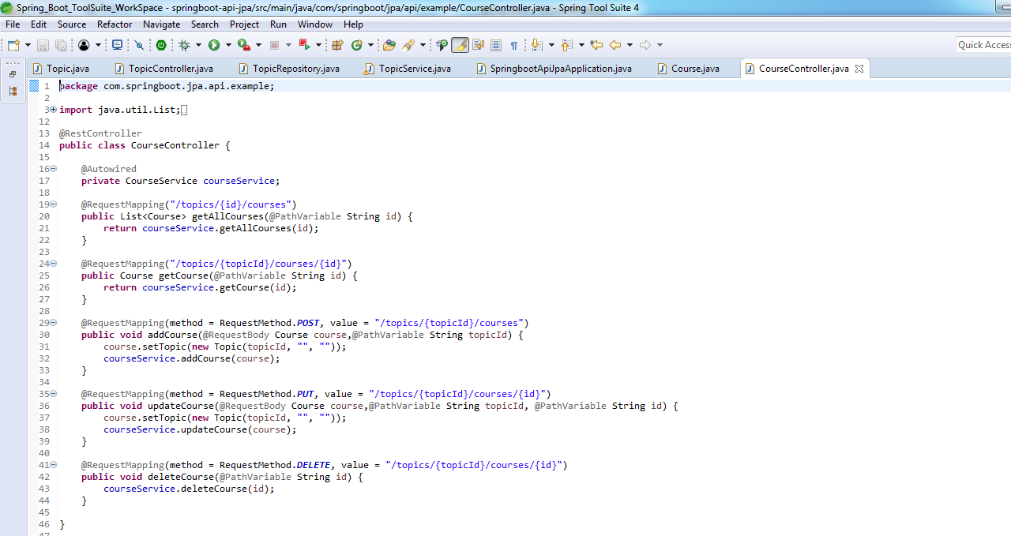

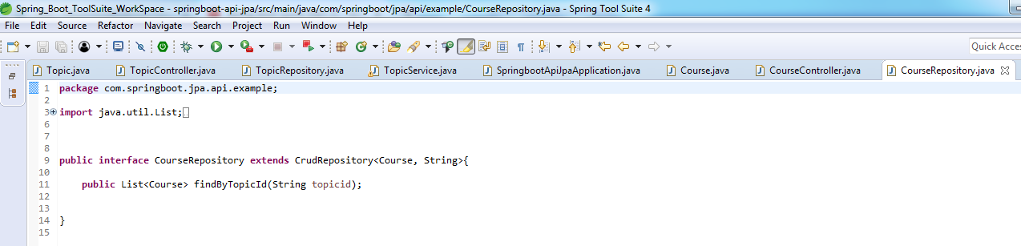

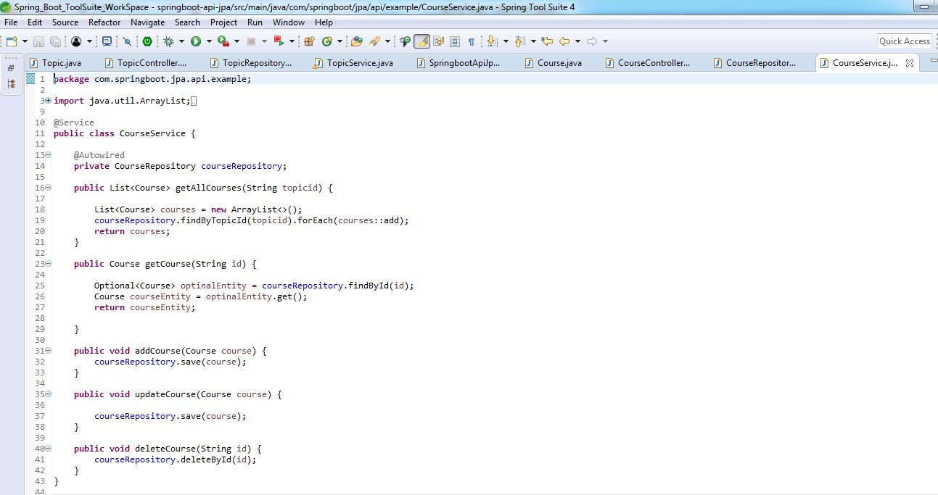

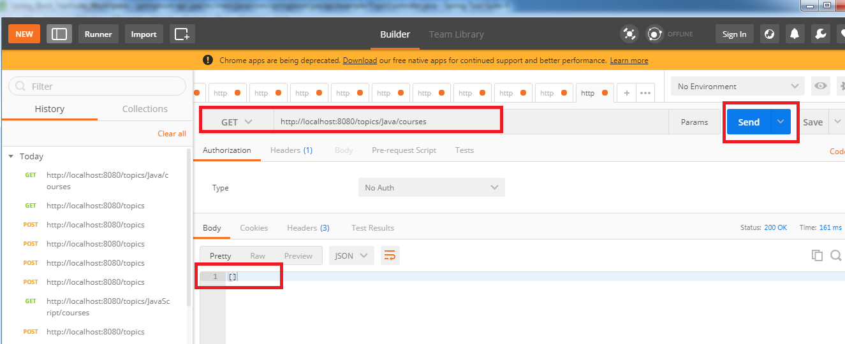

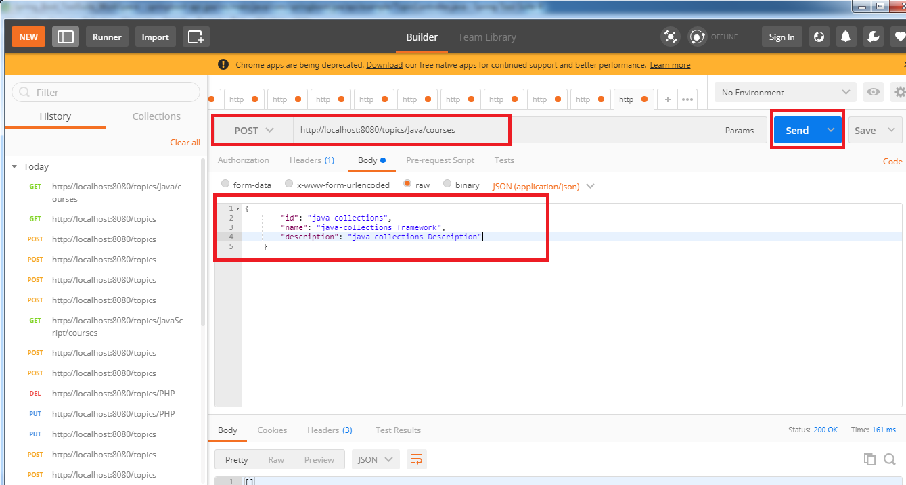

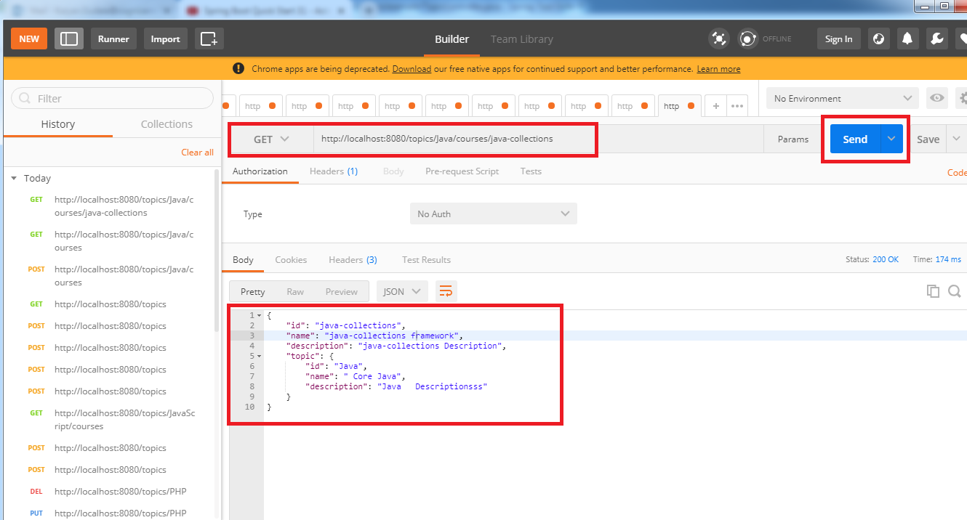

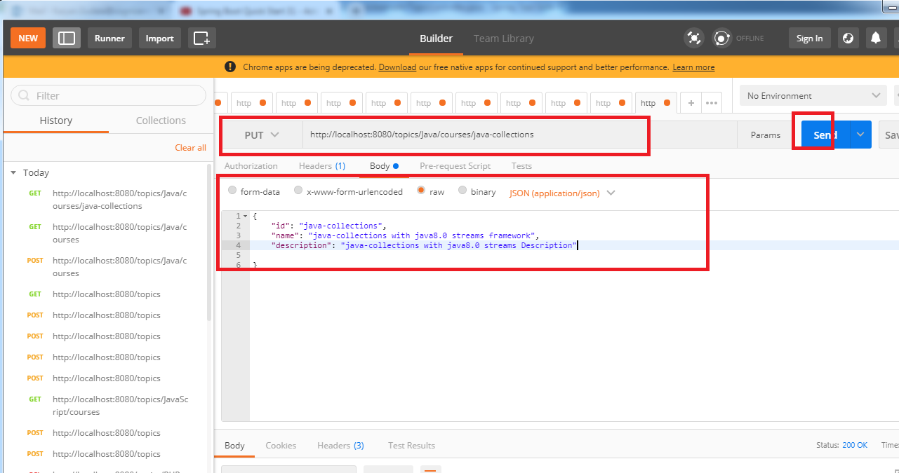

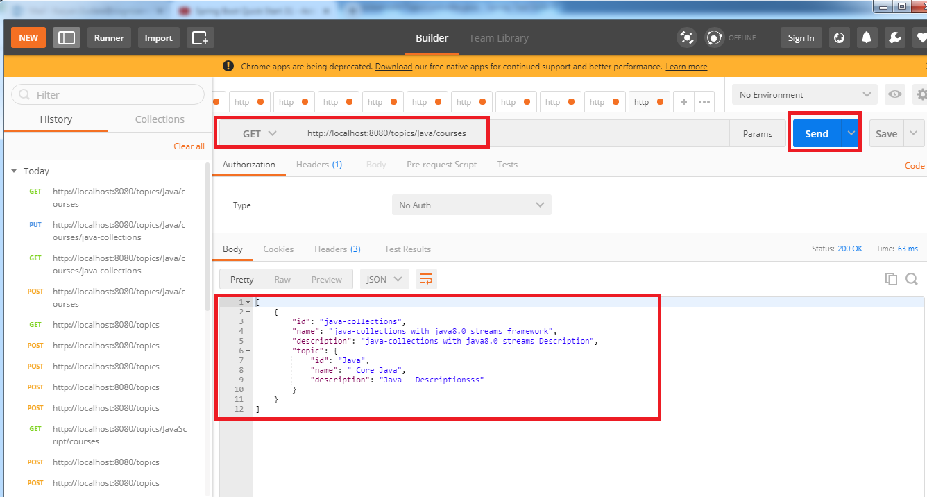

<www.javaTPoint>

<https://www.javatpoint.com/spring-maven-project>

Naresh Tech: By Sathish

<https://www.youtube.com/watch?v=t6DIyupZUYw>

Java Brains : Kaushik

<https://www.youtube.com/watch?v=bDtZvYAT5Sc&list=PLmbC-xnvykcghOSOJ1ZF6ja3aOgZAgaMO&index=8>